**Prime Innovative Hub**



**Project ID: Fall 2020-2025**

**Session: BSCS Fall 2020 to 2025**

**Project Advisor: Nazia Jehan**

**Submitted By**

|  |  |
| --- | --- |
| Fakhar Abbas | 70082821 |
| Abdul Raheem Baig | 70112370 |
|  |  |

Department of Computer Science & IT

The University of Lahore

Lahore, Pakistan

## *Declaration*

We have read the project guidelines and we understand the meaning of academic dishonesty, in particular plagiarism and collusion. We hereby declare that the work we submitted for our final year project, entitled **Prime Innovative Hub** is original work and has not been printed, published or submitted before as final year project, research work, publication or any other documentation.

## 

**Group Member 1 Name: Fakhar Abbas**

**SAP No: 70082821**

**Signature: …………………………**

**Group Member 2 Name: Abdul Raheem Baig**

**SAP No: 70112370**

**Signature: …………………………**

## *Statement of Submission*

This is to certify that **Fakhar Abbas** Roll No.**70082821, Abdul Raheem Baig 70112370** successfully submitted the final project named as: **Prime Innovative Hub**, at Computer Science & IT Department, The University of Lahore, Lahore Pakistan, to fulfill the partial requirement of the degree of **BS in Computer Science**.

**Supervisor Name: ………………………**

**Signature: …………………………**

**Date: ………………………**

## *Dedication*

This project is dedicated to my father, who taught me that the best kind of knowledge to have is that which is learned for its own sake. It is also dedicated to my mother, who taught me that even the largest task can be accomplished if it is done one step at a time.

## *Acknowledgement*

## 

We owe a huge debt of gratitude to everyone who contributed to the success of our project, **“Prime Innovative Hub – Real Estate Web Application.”**

Our heartfelt thanks go out to **Mam Nazia Jehan**, whose constant guidance, encouragement, and insightful feedback kept us focused and motivated throughout the development of this platform. Her expertise played a crucial role in helping us overcome challenges and stay aligned with our goals.

We are also incredibly grateful to **Sir Khawaja Qadeer** for his valuable suggestions, timely reviews, and unwavering support during this journey. His mentorship helped us improve and refine our ideas at every stage of the project.

We would like to extend our sincere appreciation to the **University of Lahore** for providing us with the academic environment, infrastructure, and resources necessary to bring this project to life. Their support was vital in transforming our concept into a working solution.

A big shout-out to our amazing team members, whose hard work, dedication, and collaboration made this project possible. Each individual brought unique skills to the table, and together we built something meaningful.

We also want to thank the individuals who tested our application and gave thoughtful feedback. Your insights helped us identify issues and improve user experience significantly.

Finally, we extend our gratitude to the open-source community for providing the tools and frameworks that were essential in building this system. Your contributions empowered us to innovate efficiently.

To everyone who played a role in shaping **Prime Innovative Hub**, thank you from the bottom of our hearts. We are proud of what we’ve achieved and excited about what lies ahead.

**Date:**  
June 23, 2025

## *Abstract*

In Pakistan, the real estate sector often suffers from a lack of transparency and trust, particularly when it comes to the quality and condition of properties. Buyers frequently face challenges due to unreliable property listings, misrepresented details, and the absence of professional verification. To address this critical gap, our project, Prime Innovative Hub, introduces a web-based real estate platform that not only facilitates the buying and selling of properties but also integrates a unique and trusted inspection service. This inspection feature allows buyers to make more informed decisions by reviewing professionally verified property conditions before making any commitments.

The project was developed using a role-based system where users can register as sellers, inspectors, or both. Sellers can manage their property listings, while inspectors, once approved by an admin, can offer inspection services by setting up locations and available time slots. Admins monitor the system, approve inspector applications, and ensure data quality across listings. The platform includes powerful features like advanced search filters, Google Maps integration for real-time location-based service discovery, direct communication with sellers or inspectors, and a smart chatbot to assist users in selecting areas based on their budget and preferences. The result is a reliable, transparent, and user-friendly real estate platform that builds buyer confidence and bridges the trust gap in the property market. This system demonstrates how technology can transform traditional real estate processes by making them more accountable and accessible.

***Area of the Project***

Web Base Application

***Technologies used***

The project Prime Innovative Hub is developed using a modern full-stack technology stack. For the frontend, React.js is used to build a dynamic and responsive user interface, along with HTML, CSS, and JavaScript to structure, style, and add interactivity to the web pages. The backend is developed using NestJS, a progressive Node.js framework that supports scalable server-side application development.

For the database, PostgreSQL is used to store and manage structured data, including user details, properties, services, and contact information. The project also integrates OpenAI’s API to power the chatbot, which utilizes Natural Language Processing (NLP) to assist users with real estate-related queries. Additionally, Google Maps API is used to implement geolocation features, allowing users to search and visualize properties and services based on their location. The overall development environment includes tools like Node.js, npm,

## List of Figures

Figure 1 Usecase Diagram Create Account 5

Figure 2 Architecture Diageam 7

Figure 3 ERD 7

Figure 4 Level 0 DFD 8

Figure 5 Level 1 DFD 8

Figure 6 Class Diagram 9

Figure 7 Activity Diagram Create Account 10

Figure 8 Sequence Diagram Create Account 11

Figure 9 Collaboration Diagram 12

Figure 10 State Transition Diagram 13

Figure 11 Component Diagram 14

Figure 12 Deployment Diagram 15

## List of Tables

Table 1 Functional Requirements Create Account 9

Table 2 Functional Requirements Login Account 9

Table 3 Functional Requirements Role base Redirection 10

Table 4 Functional Requirements Add Property 10

Table 5 Functional Requirements Delete/Update property 10

Table 6 Functional Requirements Submit Inspector Application 11

Table 7 Functional Requirements Approve/Reject Inspector 11

Table 8 Functional Requirements Inspector Service Add/Delete/Update 11

Table 9 Functional Requirements Property/Inspector Search 12

Table 10 Functional Requirements Map View 12

Table 11 Functional Requirements Use Chatbot 12

Table 12 Functional Requirements Admin-Delete Property 13

Table 13 use case for Create Account 18

Table 14 use case for Login Process 19

Table 15 use case for Home Page 20

Table 16 use case for Maps Navigation 21

Table 17 use case for Services 22

Table 18 use case for seller dashboard 23

Table 19 use case for inspector dashboard 24

Table 20 use case for Admin Panel 25

Table 21 use case for Contact & communication 26

Table 22 use case for Chatbot 27

Table 23 User Registration Positive 38

Table 24 User Registeration Negative 38

Table 25 User Login Positive 39

Table 26 User Login Negative 39

Table 27 Property Add By Seller Positive 40

Table 28 Property Add By Seller Negative 40

Table 29 Inspector Application Submission Positive 41

Table 30 Inspector Application Submission Negative 41

Table 31 Admin Inspector Approval (Positive) 42

Table 32 Admin Inspector Approval (Negative) 42

Table 33 Service CRUD by Inspector (Positive) 43

Table 34 Service CRUD by Inspector (Negative) 43

Table 35 Chatbot Query (Positive) 44

Table 36 Chatbot Query (Negative) 44

Table 37 Search Property Listings 45

Table 38 Invalid Property Search Filters 45

Table 39 Inspector Booking from Map 46

Table 40 Contact via Email to Seller/Inspector 46

Table 41 Chatbot Real Estate Advice 47

Table 42 Chatbot Invalid Input Handling 47

Table 43 EP Table – User Registration 48

Table 44 EP Table – Property Search 48

Table 45 EP Table – Inspector Application Submission 48

Table 46 EP Table – Admin Approval Process 48

Table 47 EP Table – Service CRUD by Inspector 48

Table 48 EP Table – Chatbot Queries 49

Table 49 BVA Table – Password Length Validation (User Registration) 49

Table 50 BVA Table – Property Price Range Filter 49

Table 51 BVA Table – Slot Time Range (Inspector Service) 49

Table 52 BVA Table – Inspector Experience Years 50

Table 53 BVA Table – Email Input Characters 50

Table 54 Decision Table – User Role Redirection After Login 50

Table 55 Decision Table – Property Search Filter Logic 51

Table 56 Decision Table – Inspector Application Review (Admin) 51

Table 57 Decision Table – Chatbot Response Scenarios 51

Table 58 Decision Table – Inspector Service CRUD Validations 51

Table 59 State Transition Table – User Registration Flow 52

Table 60 State Transition Table – Inspector Application Review 52

Table 61 State Transition Table – Property Posting by Seller 52

Table 62 State Transition Table – Chatbot Session Handling 52

Table 63 State Transition Table – Login & Role-Based Dashboard Routing 53

Table 64 Test Case 1 – Function: Register User() 57

Table 65 Test Case 2 – Function: Submit Inspector Application 58

Table 66 Test Case 3 – Function: Approve Or Reject Inspector() 58

Table 67 Test Case 4 – Function: AddProperty() 58

Table 68 Test Case 5 – Function: filterProperties() 59

Table 69 Test Case 6 – Function: ChatbotRespond() 59

Table 70 Summary Table 62

Table 71 Test Case 1 – Search Function Response Time 62

Table 72 Test Case 2 – Map Load Time 63

Table 73 Test Case 3 – Chatbot Reply Time 63

Table 74 Test Case 1 – Simulated User Surge 63

Table 75 Test Case 2 – Concurrent Inspector Applications 64

Table 76 Test Case 3 – Mass Property Upload by Sellers 64

Table 77 Test Case 1 – Role-Based Redirection Post Login 64

Table 78 Test Case 2 – Admin Approval Flow for Inspector 65

Table 79 Test Case 3 – Property Listing and Display Flow 65

Table 80 Regression Test Cycle – Example 1 66

Table 81 Regression Test Cycle – Example 2 66

Table 82 Regression Test Cycle – Example 3 66

**Table of Content**

*Declaration* i

*Statement of Submission* ii

*Dedication* iii

*Acknowledgement* iv

*Abstract* v

List of Figures vii

List of Tables viii

Chapter 1: Introduction to the Problem 1

1.1 Introduction 1

1.2 Purpose 1

1.3 Objective 1

1.4 Existing Solution 1

1.5 Proposed Solution 1

Chapter 2: Software Requirement Specification 1

2.1 Introduction 1

2.1.1 Purpose 1

2.1.2 Scope 1

2.1.3 Definitions, acronyms, and abbreviations 1

2.2 Overall description 2

2.2.1 Product perspective 2

2.2.2 Product functions 2

2.2.3 User characteristics 3

2.2.4 Constraints 3

2.2.5 Assumptions and dependencies 4

2.2.6 Apportioning of requirements 4

2.3 Specific requirements 4

2.3.1 Functional Requirement 4

2.3.2 Non-functional Requirements 4

Chapter 3: Use Case Analysis 5

Chapter 4: Design 6

4.1 Architecture Diagram 7

4.2 ERD with data dictionary 7

4.3 Data Flow diagram 8

4.3.1 The level 0 8

4.3.2 The level 1 8

4.4 Class Diagram 9

4.5 Activity Diagram 10

4.6 Sequence Diagram 11

4.7 Collaboration Diagram 12

4.8 State Transition Diagram 13

4.9 Component Diagram 14

4.10 Deployment Diagram 15

Chapter 5: Testing 16

5.1 Test Case Specifications 16

5.2 Black Box Test Cases 17

5.2.1 Equivalence Partitions (EP) 17

5.2.2 Boundary Value Analysis 18

5.2.3 Decision Table Testing 18

5.2.4 State transition Testing 18

5.2.5 Use Case Testing 18

5.3 White Box Test Cases 18

5.3.1 Cyclometric complexity 18

5.4 Performance testing 19

5.5 Stress Testing 19

5.6 System Testing 19

5.7 Regression Testing 19

5.7.1 Selecting Regression Tests 20

5.7.2 Regression Testing Steps 20

Chapter 6: Tools and Techniques 21

Chapter 7: Summary and Conclusion 22

Chapter 8: User Manual 23

Chapter 9: Lessons Learnt and Future Work 24

References 25

Appendix 26

### Chapter 1: Introduction to the Problem

##### Introduction

In the real estate sector of Pakistan, both buyers and sellers face significant challenges in terms of trust, transparency, and accessibility. Property listings are often outdated or misleading, and there is usually no standardized system to verify the condition or legitimacy of properties. Moreover, there is a lack of centralized platforms that allow users to access reliable inspection services or easily connect with sellers and inspectors in a specific area. This creates uncertainty and inefficiencies in property transactions.

To address these issues, the project **Prime Innovative Hub** is proposed as a comprehensive web-based platform that streamlines real estate activities by allowing users to search, list, and inspect properties in a transparent and organized manner. The integration of modern technologies such as AI-powered chatbots, Google Maps for geolocation, and verified user roles (seller and inspector) ensures that users have a reliable and interactive experience. By solving real-world problems in property dealings, this project aims to bridge the gap between digital innovation and the traditional real estate market.

##### Purpose

The purpose of developing Prime Innovative Hub is to bring authenticity and trust to the real estate market by introducing a system where users can access verified property inspection services. In many cases, buyers face uncertainty due to misleading or incomplete property listings, which can lead to financial loss and dissatisfaction. This project addresses that issue by allowing users to hire approved inspectors who evaluate the condition of properties before purchase, ensuring transparency and informed decision-making. By integrating inspection as a core feature, the platform not only reduces the risk of fraud but also promotes safer and more reliable property transactions in society.

##### Objective

The main objective of **Prime Innovative Hub** is to develop a reliable, user-friendly web platform that connects property buyers, sellers, and inspectors in a secure, transparent environment. A core goal is to introduce a verified inspection system that helps buyers make confident decisions by ensuring property details are accurate and professionally assessed. The platform includes advanced search filters, Google Maps integration, and seamless user-to-service communication.

It also offers separate dashboards for sellers and inspectors to manage listings and services efficiently. The admin panel verifies inspector applications and monitors platform activity to ensure only approved services are accessible. An AI-powered chatbot enhances the user experience with instant responses and real estate guidance. Overall, the project aims to improve the credibility and efficiency of property transactions through digital innovation.

##### Existing Solution

In the current real estate market, platforms like Zameen.com and OLX provide users with the ability to search, view, and list properties online. These platforms offer basic filters such as location, price, and property type, making it easier for buyers and sellers to connect. However, one of the major shortcomings of these existing solutions is the lack of any verified propertyinspection system. Buyers have no way of knowing the actual condition of a property before visiting or purchasing, which often leads to misinformation, hidden defects, and ultimately, a lack of trust in the transaction process.

Another issue with these platforms is the absence of admin moderation and structured role-based access. There is no dedicated panel for property inspectors, and sellers are not required to verify their listings through any standardized process. This creates a gap in reliability, as anyone can post property details without validation. Moreover, communication between buyers, sellers, and service providers is unstructured, and there's no intelligent system like a chatbot to guide users. These limitations highlight the need for an improved system—one that introduces inspection asan integral part of the real estate process, offering transparency, accountability, and confidence to users.

##### Proposed Solution

To address the limitations of existing real estate platforms, we have proposed Prime Innovative Hub, a web-based solution that not only allows users to search and list properties but also introduces a verified property inspection system a unique feature currently missing in the market. This system enables buyers to connect with approved inspectors who can professionally assess the condition of a property before a purchase decision is made. Inspectors are required to submit an application, which is reviewed by an admin, ensuring only trusted individuals are allowed to offer inspection services. This adds a crucial layer of authenticity and trust to the property-buying process.

In addition, our platform offers role-based dashboards for sellers and inspectors, a centralizedadmin panel for monitoring and approval, Google Maps integration for location-based property and service discovery, and an AI-powered chatbot to assist users with queries, budget suggestions, and area recommendations. Unlike existing solutions, Prime Innovative Hub focuses on providing a secure, verified, and user-personalized experience, ensuring transparency and accountability at every stage of the transaction. By bridging the trust gap and offering features not available on current platforms, our system presents a more complete and reliable real estate solution for the market.

### Chapter 2: Software Requirement Specification

##### Introduction

###### Purpose

The "Prime Innovative Hub" project aims to provide a comprehensive web-based platform that simplifies and authenticates the real estate experience for buyers, sellers, and inspectors. The main objectives of the project are as follows:

**Ensuring Authenticity through Property Inspections:**  
A core purpose of this project is to introduce verified property inspections as an integral part of the real estate process. Unlike existing platforms that rely solely on user-submitted information, Prime Innovative Hub enables users to connect with approved inspectors who can professionally assess property conditions. This feature brings a new level of trust and reliability to property transactions, helping buyers make more informed decisions.

**Facilitating Role-Based Dashboards:**  
The system provides customized dashboards for sellers and inspectors. Sellers can list, manage, and update their properties, while inspectors can manage their services, schedule slots, and define service areas. This separation ensures a structured and user-centric workflow tailored to each role's responsibilities.

**Simplifying Search and Discovery:**  
To make property browsing efficient, the platform offers advanced search filters and Google Maps integration. Users can filter listings by city, location, price, and property type (rent or buy), and view both properties and inspectors visually on the map. This feature streamlines the property discovery process and helps users find relevant services based on location.

**Enhancing User Support through AI Chatbot:**  
The platform features an AI-powered chatbot integrated with Open AI to guide users throughout their journey. It can assist with common questions, budget-based area suggestions, and general real estate queries, providing a smart and interactive experience even for first-time users.

**Improving Transparency and Communication:**  
Buyers can directly contact sellers or inspectors through email or phone based on the listing details. This clear communication channel eliminates middlemen and enhances trust between parties. The admin panel further ensures transparency by reviewing and approving inspector applications and managing all listings.

**2) Specific Audience for the SRS:**

**Development Team:**  
This document is intended for the developers responsible for building Prime Innovative Hub. It provides them with clear, structured requirements for implementing each feature and integration accurately.

**Project Managers:**  
Project managers will use the SRS to track development progress, manage timelines, assign tasks, and ensure the project stays within defined scope and budget.

**Quality Assurance (QA) Team:**  
The QA team will use this document to develop and execute test cases to verify that all features meet both functional and non-functional requirements.

**Stakeholders/Clients:**  
Supervisors, evaluators, and potential investors will refer to the SRS to understand the goals, scope, and expected deliverables of the system. It ensures alignment between the project vision and actual implementation.

**Maintenance and Support Team:**  
Post-deployment, this document will guide support teams in resolving bugs, implementing feature enhancements, and maintaining overall platform quality.

**End Users (Indirectly):**  
Though not the direct readers of the SRS, the needs and expectations of end users—buyers, sellers, and inspectors are central to the system. The document ensures that the final product is user-friendly, secure, and effective in solving real-world real estate problems.

###### Scope

1. **Software Product Name:**  
   The software product to be developed is named **"Prime Innovative Hub."**
2. **What the Software Will Do:**

a. Allow users to register as sellers, inspectors, or both, and access dedicated dashboards.  
b. Enable sellers to list, update, and manage their property postings.  
c. Enable inspectors to submit applications for approval and, once verified, offer property inspection services.  
d. Display approved properties and inspection services on the frontend with filtering options (city, price, rent/buy, etc.).  
e. Integrate Google Maps to show real-time property and inspector locations.  
f. Provide an AI-powered chatbot to assist users with queries and area suggestions.  
g. Facilitate direct communication between users via email and contact number visibility.  
h. Include an admin panel to manage property listings and approve/reject inspector applications.

**What the Software Will Not Do:**

a. Will not handle financial transactions, such as online payments or escrow services.  
b. Will not perform legal verification of property ownership or documentation.  
c. Will not allow unverified inspectors to offer services publicly.  
d. Will not provide mobile app functionality in the initial version.

1. **Application of the Software:**

**Prime Innovative Hub** is intended to serve property buyers, sellers, and professional property inspectors, primarily within the real estate market of Pakistan. The platform is designed for web access and will provide a centralized hub for secure, transparent, and well-informed real estate interactions.

1. **Relevant Benefits, Objectives, and Goals:**

**Relevant Benefits:**  
a. Introduces inspection as a verified and trackable service, building trust in property transactions.  
b. Offers role-based functionality to streamline workflows for sellers and inspectors.  
c. Improves user experience with location-based services and intelligent chatbot support.  
d. Ensures content authenticity through admin moderation and service approval mechanisms.  
e. Reduces fraud and misinformation by enabling professional inspections before purchase decisions.

**Objectives and Goals:**  
a. Improve trust and transparency in the online real estate market.  
b. Empower users to make informed decisions through verified property inspections.  
c. Enhance property search and service discovery through intuitive design and map integration.  
d. Establish a scalable foundation for future features like payments, reviews, or mobile applications

###### Definitions, acronyms, and abbreviations

This subsection provides the definitions of key terms, acronyms, and abbreviations used throughout the Software Requirement Specification (SRS) document to ensure clarity and consistency.

**Definitions**:

* **User**: A person who registers and interacts with the system. A user can be a buyer, seller, inspector, or admin.
* **Seller**: A registered user who lists properties for sale or rent on the platform.
* **Inspector**: A professional who provides property inspection services after being approved by the admin.
* **Admin**: The system administrator responsible for managing users, verifying inspectors, and moderating listings.
* **Inspection**: A professional evaluation of a property's condition, requested by a user and conducted by an approved inspector.
* **Dashboard**: A personalized interface where users (seller or inspector) can manage their listings or services.
* **Chatbot**: An AI-powered virtual assistant that answers user queries, provides suggestions, and helps with navigation.
* **Listing**: A property posted by a seller with detailed information such as location, price, type, and availability.

##### Overall description

**System Interfaces:**

The system will interact with:

* **Google Maps API** for visualizing property and inspector locations.
* **OpenAI API** for chatbot support.
* **SMTP or mailing service** for sending inquiry emails from customers to sellers/inspectors.
* **Database (PostgreSQL)** to store user, property, service, and contact information.

**User Interfaces:**

The application will provide the following user interfaces:

* **Home Page**: Search bar with filters (city, price, rent/buy) and featured listings.
* **Maps Page**: Google Map view showing available properties and inspectors by city.
* **Services Page**: Search for available inspection services with filters.
* **Dashboards**:
  + **Seller Dashboard**: For managing property listings (CRUD).
  + **Inspector Dashboard**: For managing services, slots, and locations.
  + **Admin Panel**: For moderating properties and approving/rejecting inspector applications.
* **Login/Signup Pages**: With role selection (seller, inspector, or both).
* **Chatbot Interface**: For real-time guidance and support.

**Hardware Interfaces:**

There are no specific hardware dependencies. The application will run on standard computing devices (laptops/desktops/tablets) with an internet connection. No special hardware is required for users or admins.

**Software Interfaces:**

* **Frontend**: Built using React.js (JavaScript framework)
* **Backend**: Developed with NestJS (Node.js framework)
* **Database**: PostgreSQL
* **External APIs**:
  + Google Maps API
  + OpenAI API for chatbot
* **Server Requirements**:
  + Node.js runtime
  + PostgreSQL support
  + RESTful API framework compatibility

**Communications Interfaces:**

* Uses **HTTPS** for secure web communication.
* Communicates with APIs using **RESTful protocol**.
* Relies on **SMTP or Email API** for message delivery between users (inquiries).
* Hosting assumes a **cloud server** with internet access.

**Memory Requirements:**

* **Primary Memory** (RAM): Minimum 4 GB RAM recommended for local development.
* **Secondary Storage**: Minimum 10 GB disk space required on the server to store application code, assets, logs, and database.
* The PostgreSQL database will scale based on property listings, user accounts, and service data.

**Operations:**

* **Normal operations** include user login, property listing, inspection booking, and admin verification.
* **Special operations** include:
  + **Admin panel actions**: Accept/reject inspector applications, delete property listings.
  + **Chatbot communication**
  + **Data backup**: Daily scheduled database backups (can be implemented via cron jobs or cloud functions).
  + **Error recovery**: Logging and error-handling mechanisms will be in place to recover from failures gracefully.

**Site Adaptation Requirements:**

* The system can be deployed for different cities or regions by initializing relevant city/location data.
* Admin credentials, email configuration, Google Maps API keys, and chatbot API tokens must be set up at each site.
* Language localization and currency format (e.g., PKR) can be adapted depending on geographic expansion.

###### Product perspective

###### Product functions

The system is composed of several functional modules that interact to provide a seamless user experience. These modules handle account management, property listings, inspection services, chatbot support, search and filtering, and admin moderation. Each function is critical in fulfilling the project's goal of providing a trusted, interactive real estate platform.

Below are the defined functional requirements using the standard format.

|  |  |  |  |  |
| --- | --- | --- | --- | --- |
| ID: | FR_01 |  |  |  |
| Name: | Create Account |  |  |  |
| Description | Input | Output | Requirements | Basic Work Flow |
| Enter details to create account | Name,Email, Password,Confirm Password,Phone, Select Role. | Account created | Internet Connectivity required | Enter correct information and click submit button  System save the record in database |

Table 1 Functional Requirements Create Account

|  |  |  |  |  |
| --- | --- | --- | --- | --- |
| ID: | FR_02 |  |  |  |
| Name: | Login Account |  |  |  |
| Description | Input | Output | Requirements | Basic Work Flow |
| Allows users to log in | Email, Password | User redirected to their dashboards | Internet Connectivity required | Enter valid credentials and click login.  System verifies and redirects user. |

Table 2 Functional Requirements Login Account

|  |  |  |  |  |
| --- | --- | --- | --- | --- |
| ID: | FR_03 |  |  |  |
| Name: | Role base Redirection |  |  |  |
| Description | Input | Output | Requirements | Basic Work Flow |
| Allows users to redirect according to role base | Check role | User redirected to their dashboards | Internet Connectivity required | Select Role whether want to login in Dasboard |

Table 3 Functional Requirements Role base Redirection

|  |  |  |  |  |
| --- | --- | --- | --- | --- |
| ID: | FR_04 |  |  |  |
| Name: | Add Property |  |  |  |
| Description | Input | Output | Requirements | Basic Work Flow |
| Seller can add new property listings. | Property title, location, price, type (rent/sell), images etc, | Property listed on frontend | Internet Connectivity required | Seller fills form; system validates and stores property. |

Table 4 Functional Requirements Add Property

|  |  |  |  |  |
| --- | --- | --- | --- | --- |
| ID: | FR_05 |  |  |  |
| Name: | Delete/Update  Property |  |  |  |
| Description | Input | Output | Requirements | Basic Work Flow |
| Seller can update/delete existing property listings | Property IdProperty title, location, price, type (rent/sell), images etc, | Property listed updated or deleted on frontend | Internet Connectivity required | Seller fills form; system validates and stores property. |

Table 5 Functional Requirements Delete/Update property

|  |  |  |  |  |
| --- | --- | --- | --- | --- |
| ID: | FR_06 |  |  |  |
| Name: | Submit Inspector Application |  |  |  |
| Description | Input | Output | Requirements | Basic Work Flow |
| Inspector submits application to be verified by admin. | Inspector info, experience letter image, work experience select inspection type | User Application will be send to admin panel | Internet Connectivity required | User fill form to apply for inspector in our organization |

Table 6 Functional Requirements Submit Inspector Application

|  |  |  |  |  |
| --- | --- | --- | --- | --- |
| ID: | FR_07 |  |  |  |
| Name: | Approve/Reject Inspector |  |  |  |
| Description | Input | Output | Requirements | Basic Work Flow |
| Admin reviews inspector applications and approves or rejects. | Inspector ID,Approve or Reject | Application status updated | Internet Connectivity required | Admin views list, selects application, approves/rejects. |

Table 7 Functional Requirements Approve/Reject Inspector

|  |  |  |  |  |
| --- | --- | --- | --- | --- |
| ID: | FR_08 |  |  |  |
| Name: | Inspector Service Add/Delete/Update |  |  |  |
| Description | Input | Output | Requirements | Basic Work Flow |
| Approved inspector can manage services, slots, and locations. | Service details, slot timings, location info | Service shown in frontend listings and filters | Internet Connectivity required | Inspector fills form; system updates data. |

Table 8 Functional Requirements Inspector Service Add/Delete/Update

|  |  |  |  |  |
| --- | --- | --- | --- | --- |
| ID: | FR_09 |  |  |  |
| Name: | Property/Inspector Search |  |  |  |
| Description | Input | Output | Requirements | Basic Work Flow |
| Users can search properties and services using filters. | City, price, rent/buy, location | Filtered search results displayed | Internet Connectivity required | User enters filters; system returns matched results. |

Table 9 Functional Requirements Property/Inspector Search

|  |  |  |  |  |
| --- | --- | --- | --- | --- |
| ID: | FR_10 |  |  |  |
| Name: | Map View |  |  |  |
| Description | Input | Output | Requirements | Basic Work Flow |
| Displays properties and inspectors on Google Map. | Selected city or area | Map with location pins | Internet Connectivity required | User selects location; map displays corresponding pins. |

Table 10 Functional Requirements Map View

|  |  |  |  |  |
| --- | --- | --- | --- | --- |
| ID: | FR_11 |  |  |  |
| Name: | Use Chatbot |  |  |  |
| Description | Input | Output | Requirements | Basic Work Flow |
| User can ask real estate-related questions via chatbot. | User question | AI-generated answer | Internet Connectivity required | User types query; chatbot processes and replies. |

Table 11 Functional Requirements Use Chatbot

|  |  |  |  |  |
| --- | --- | --- | --- | --- |
| ID: | FR_12 |  |  |  |
| Name: | Admin – Delete Property |  |  |  |
| Description | Input | Output | Requirements | Basic Work Flow |
| Admin can delete any property from system. | Property ID | Property removed permanently | Internet Connectivity required | Admin selects and deletes listing; update reflected on frontend. |

Table 12 Functional Requirements Admin-Delete Property

###### User characteristics

* **Diverse User Roles:** Users of the platform include **property buyers**, **property sellers**, **certified inspectors**, and **administrators**, each with different goals and system access levels.
* **Real Estate Participants:** Users may include **first-time homebuyers, property investors, rental seekers,** and **independent sellers**, all seeking an intuitive and secure property platform.
* **Moderate Technical Knowledge:** Most users are expected to have **basic computer literacy** and familiarity with browsing websites, filling out forms, using search filters, and viewing maps.
* **Service Providers (Inspectors):** Inspectors are likely to have **professional or semi-professional backgrounds,** capable of handling digital tools for service listings, slot management, and location mapping.
* **Admin Users:** Admins will possess **higher technical understanding**, responsible for moderating listings, reviewing inspector applications, and maintaining platform integrity.
* **Trust-Focused Users:** Buyers and sellers are particularly concerned with **authenticity, transparency, and reliability** in transactions, and will be drawn to features like verified inspections and direct contact.
* **Multi-Device Access:** Users may access the platform from **desktop computers, laptops, tablets, or mobile devices,** and expect a consistent experience across all.
* **Location-Oriented Users:** Many users will rely heavily on **map-based searches** and filtering by city or locality to find nearby properties and inspection services.
* **Feedback-Oriented:** Users, especially sellers and inspectors, may provide **feedback or report issues** to improve their experience, enabling ongoing platform enhancement

###### Constraints

* **Regulatory Policies:**  
  The system must comply with local **data protection and privacy regulations** in Pakistan. Any user data collected (e.g., emails, contact numbers) must be securely stored and not misused or exposed to third parties.
* **Hardware Limitations:**  
  The platform is optimized for modern web browsers and standard computing devices. Performance may degrade on devices with **low processing power or outdated browsers**.
* **Interfaces to Other Applications:**  
  The system depends on **external APIs** such as **Google Maps API** for location services and **OpenAI API** for chatbot functionality. Any changes, outages, or limitations in these APIs may impact system behavior.
* **Parallel Operation:**  
  The application is designed as a **single-instance platform** and is not currently intended for distributed deployment across multiple nodes or regions in parallel.
* **Audit Functions:**  
  Admin users have limited **manual control for auditing**, such as viewing inspector applications and property listings. There is currently no automatic activity logging or version history tracking implemented.
* **Control Functions:**  
  Only admin users have access to platform-wide control functions such as **inspector approval/rejection** and **property moderation**.
* **Higher-Order Language Requirements:**  
  The system is developed using **JavaScript and TypeScript**, specifically with **React.js** on the frontend and **NestJS** on the backend. The choice of frameworks may limit portability to other tech stacks without substantial modification.
* **Signal Handshake Protocols:**  
  Not applicable, as the system does not involve hardware-level communications or embedded systems requiring signal protocols.
* **Reliability Requirements:**  
  As a real estate platform, **high availability and responsiveness** are expected. However, full fault-tolerance or zero-downtime is not guaranteed in this version and depends on server deployment and third-party service stability.
* **Criticality of the Application:**  
  The application is **moderately critical**, especially regarding trust and data accuracy. False information or failed inspection approval workflows could directly impact user decisions and credibility.
* **Safety and Security Considerations:**  
  User authentication is handled via password-based login. The system must implement **form validation, input sanitization**, and **role-based access control** to prevent unauthorized access and protect user data. Admin functions must be strictly protected through credential checks.

###### Assumptions and dependencies

The development and functionality of Prime Innovative Hub are based on several key assumptions and dependencies. It is assumed that users will have access to a stable internet connection and use modern web browsers to access the platform. The system relies on third-party services such as Google Maps API for geolocation and open AI API for chatbot support; any changes or outages in these services may impact system features. It is also assumed that an active admin will be available to review inspector applications and moderate property listings to maintain platform trust. The platform depends on a secure hosting environment for data protection and performance, and on a functioning email service for user-to-user communication. Additionally, it is assumed that users will provide accurate and honest information when registering or listing properties. Any change in these assumptions could require modifications in the system’s design or functionality.

###### Apportioning of requirements

While the initial version of **Prime Innovative Hub** focuses on core functionalities such as user registration, property listing, inspector application, admin moderation, map-based search, and chatbot support, some features have been identified for future development. These include the integration of an online payment gateway for booking inspection services, a user rating and review system for inspectors and sellers, push notifications for activity updates, mobile application versions for Android and iOS, multilingual support, and detailed analytics for admin users. These enhancements are not essential for the current release but will significantly improve user experience, scalability, and operational efficiency in later versions of the system.

##### Specific requirements

This section describes the functional and non-functional requirements of the Prime Innovative Hub system in detail to help the designers and testers ensure the system is developed according to the user’s expectations and verified appropriately.

###### Functional Requirement

The key functions/modules of the Prime Innovative Hub project include:

* **User Registration Module:**  
  Allows users to register as a seller, inspector, or both. Role-based access is provided upon signup.
* **Login & Authentication Module:**  
  Enables secure login and redirects users to their respective dashboards (Seller, Inspector, Admin).
* **Seller Dashboard Module:**  
  Allows sellers to perform CRUD operations on property listings.
* **Inspector Dashboard Module:**  
  Enables approved inspectors to create and manage inspection services, including setting time slots and service locations.
* **Inspector Application Module:**  
  Allows newly registered inspectors to submit applications for admin review and approval.
* **Admin Panel Module:**  
  Provides admin with controls to view all properties, approve/reject inspector applications, and delete any property listing.
* **Search and Filter Module:**  
  Allows users to search for properties and services using filters like city, location, price, and rent/sale status.
* **Google Maps Integration Module:**  
  Displays pins for properties and inspectors based on user input for city or area.
* **Contact Module:**  
  Allows users to send inquiry messages to sellers or inspectors via a contact form (email-based communication).
* **Chatbot Module:**  
  Integrates AI-powered chatbot to assist users with area suggestions, budget planning, and general real estate queries.

###### Non-functional Requirements

• **Usability:**  
The system will have an intuitive user interface, ensuring ease of use for individuals with basic computer skills. Role-specific dashboards will simplify user workflows.

• **Reliability:**  
The system will operate with a high degree of reliability, ensuring that all services (e.g., login, chatbot, map view) function correctly under normal usage without unexpected failures.

• **Performance:**  
The application will respond to user actions, such as searching, logging in, and chatbot interaction, within 2–3 seconds. The map and filtered results will load smoothly.

• **Design Constraints:**  
The system is developed using **React.js** for frontend, **NestJS** for backend, and **PostgreSQL** for the database. It must remain compatible with these technologies during enhancements.

• **Portability:**  
The platform will be accessible through all modern web browsers and devices, including desktops, laptops, tablets, and smartphones. The architecture supports future deployment on cloud platforms.

# Chapter 3: Use Case Analysis

There are following use Case diagrams of Functional requirements:

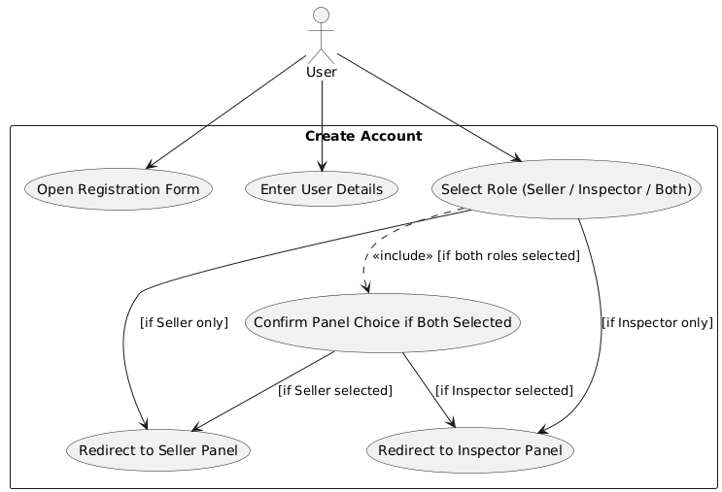

Figure 1 use case for Create Account

Usecase diagram detail:

|  |  |  |
| --- | --- | --- |
| Use Case ID | UC_01 | |
| Use Case Name | Create Account | |
| Description | |  | | --- | | This use case describes the process of registering a new user in the Prime Innovative Hub real estate platform, either as a Seller, Inspector, or both. |  |  | | --- | |  | | |
| Primary Actor | User | |
| Secondary Actor | None | |
| Pre-Condition | The user must have internet access and reach the Sign-Up page via the Login screen.  The user has not registered on the system previously. | |
| Post-Condition | A new user account is created and saved in the database The user is redirected based on the selected role(s):  Seller Dashboard, Inspector Application, or both. | |
| Basic Flow | Actor Action | System Action |
|  | 1) The user opens the Login page and clicks on "Sign Up".  2) The user fills in personal information (e.g., name, email, password).  3) The user selects their role(s) via checkboxes (Seller, Inspector, or both).  4) The user submits the registration form. | 1) The system displays the Sign-Up form.  2) The system validates the input data.  3) The system creates a new user account and stores it in the database.  4) If one role is selected, redirect the user to the corresponding dashboard (Seller or Inspector Application).  5) If both roles are selected, the system prompts the user to choose which dashboard to proceed to. |
| Alternate Flow | **Actor Action:**  The user enters an already registered email.  **System Action:**  The system shows an error message: "Email already in use. Please log in or use a different email." | |

Table 13 use case for Create Account

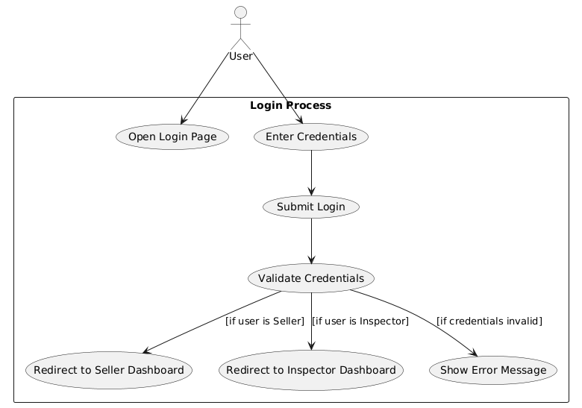

Figure 2 use case for Login Process

|  |  |  |
| --- | --- | --- |
| Use Case ID | UC_02 | |
| Use Case Name | Login Process | |
| Description | This use case describes how a registered user logs into the Prime Innovative Hub system and is redirected to their respective dashboard based on their role. | |
| Primary Actor | User | |
| Secondary Actor | None | |
| Pre-Condition | The user must have a registered account in the system.  The user must be on the Login page with access to internet. | |
| Post-Condition | - If credentials are valid, the user is redirected to either the Seller or Inspector dashboard based on their role.  - If credentials are invalid, an error message is shown. | |
| Basic Flow | Actor Action | System Action |
|  | 1) The user opens the Login page.  2) The user enters login credentials (email and password).  3) The user submits the login form. | 1) The system receives the credentials and validates them.  2) If credentials are correct:    - If the user is a Seller, redirect to the Seller Dashboard.    - If the user is an Inspector, redirect to the Inspector Dashboard.  3) If credentials are invalid, display an error message. |
| Alternate Flow | |  | | --- | |  |  |  | | --- | | **Actor Action:**  The user enters incorrect credentials.  **System Action:**  The system displays an error message: "Invalid email or password." | | |

Table 14 use case for Login Process

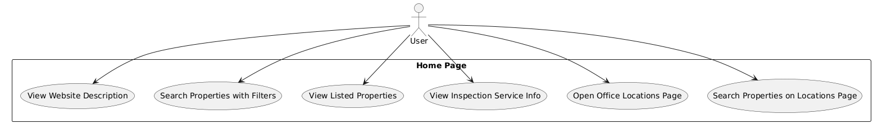

Figure 3 use case for home page

|  |  |  |
| --- | --- | --- |
| Use Case ID | UC_03 | |
| Use Case Name | Access Home Page Features | |
| Description | This use case describes the various interactions a user can perform on the Home Page of the Prime Innovative Hub platform. | |
| Primary Actor | User | |
| Secondary Actor | None | |
| Pre-Condition | The user has accessed the website's home page with an internet-connected device. | |
| Post-Condition | The user is able to explore different sections such as property filters, listings, inspection info, and location-based property searches. | |
| Basic Flow | Actor Action | System Action |
|  | 1) The user opens the Home Page.  2) The user can:    - View the website description.    - Search properties using filters (city, location, price, buy/rent).    - View a list of featured or latest properties.    - View information about inspection services offered.    - Open the office locations page for inspection availability.    - Search properties from the office locations page. | - Loads the requested content dynamically based on the user’s actions (e.g., display property listings, filter results, show office maps). |
| Alternate Flow | **Actor Action:**  The user applies a filter that yields no results.  **System Action:**  Displays a message like “No properties found for the selected criteria.” and prompts the user to adjust filters. | |

Table 15 use case for Home Page

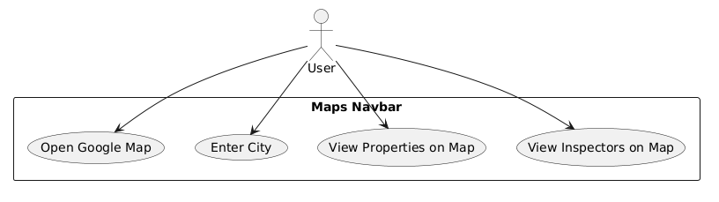

Figure 4 use case for maps navbar

|  |  |  |
| --- | --- | --- |
| Use Case ID | UC_04 | |
| Use Case Name | View Properties and Inspectors on Map | |
| Description | This use case describes how a user interacts with the Maps section to view properties and available inspectors within a selected city using Google Maps integration. | |
| Primary Actor | User | |
| Secondary Actor | None | |
| Pre-Condition | |  | | --- | |  |  |  | | --- | | - The user has internet access and navigates to the Maps section.  - Google Maps API is successfully loaded. | | |
| Post-Condition | - The system displays a map centered on the selected city.  - Property and inspector markers are shown on the map based on availability. | |
| Basic Flow | Actor Action | System Action |
|  | 1) The user navigates to the Maps navbar.  2) The user clicks to open Google Map.  3) The user enters a city in the search box.  4) The user can toggle to view either properties or inspectors. | 1) Google Map loads within the application.  2) The system centers the map based on the entered city.  3) The system fetches and displays properties and inspector locations as map markers.  4) Marker info displays brief details (name, address, contact) on click. |
| Alternate Flow | |  | | --- | |  |  |  | | --- | | **Actor Action:**  User enters an invalid city or there are no results for that location.  **System Action:**  Displays a message like “No properties or inspectors found in this city. Try another location.” | | |

Table 16 use case for Maps Navigation

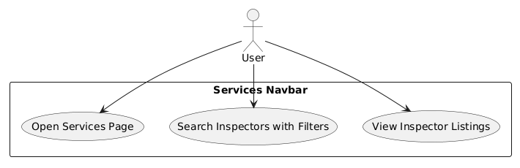

Figure 5 use case for Services

|  |  |  |
| --- | --- | --- |
| Use Case ID | UC_05 | |
| Use Case Name | Explore Inspector Services | |
| Description | This use case describes how a user interacts with the Services section to view and filter inspector service listings based on city, location, and price. | |
| Primary Actor | User | |
| Secondary Actor | None | |
| Pre-Condition | - The user is on the Services page.  - The inspector(s) have published services. | |
| Post-Condition | - The system displays available inspectors and their services based on selected filters. | |
| Basic Flow | Actor Action | System Action |
|  | 1) The user clicks the “Services” navbar item.  2) The user sees a service search bar.  3) The user applies filters such as city, price, and availability.  4) The user views a list of available inspectors and their service details. | 1) Loads the Services page with the search interface.  2) Fetches inspectors from the database who have approved services.  3) Filters the inspector listings based on user inputs.  4) Displays filtered inspector listings with details like location, service type, slots, and contact options. |
| Alternate Flow | **Actor Action:**  The user applies filters with no matching inspectors.  **System Action:**  Displays a message like: “No inspectors found matching your criteria.” and prompts to reset filters. | |

Table 17 use case for Services

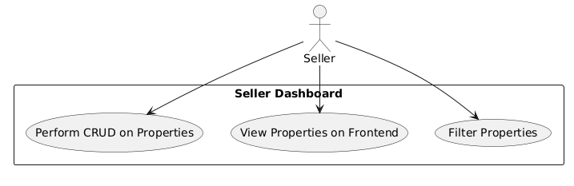

Figure 6 use case for seller dashboard

|  |  |  |
| --- | --- | --- |
| Use Case ID | UC_06 | |
| Use Case Name | Manage Seller Dashboard | |
| Description | This use case describes how a Seller manages their dashboard to create, update, delete, and view their property listings, as well as filter and preview them on the frontend. | |
| Primary Actor | Seller | |
| Secondary Actor | None | |
| Pre-Condition | - The seller is logged into their account.  - Seller has an active account approved by the system. | |
| Post-Condition | - Properties are successfully managed in the system and reflected on the frontend for users. | |
| Basic Flow | Actor Action | System Action |
|  | 1) The seller logs into the dashboard.  2) Seller creates a new property listing with relevant details.  3) Seller edits or deletes existing properties.  4) Seller views the list of their properties.  5) Seller applies filters (e.g., city, price) to find specific properties.  6) Seller previews how their listings appear on the frontend. | 1) Displays the seller dashboard with all tools.  2) Saves new or updated property data to the database.  3) Reflects changes on the public listing view.  4) Filters and returns relevant property data. |
| Alternate Flow | **Actor Action:**  Seller enters incomplete property data.  **System Action:**  Prompts the seller to fill all required fields before submission.   **Actor Action:** Seller tries to delete a property that doesn’t exist.  **System Action:** Displays: “Property not found or already deleted.” | |

Table 18 use case for seller dashboard

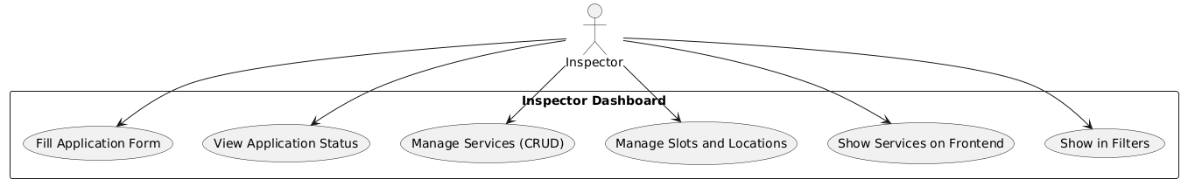

Figure 7 use case for inspector Dashboard

|  |  |  |
| --- | --- | --- |
| Use Case ID | UC_07 | |
| Use Case Name | Manage Inspector Dashboard | |
| Description | This use case describes how an Inspector interacts with their dashboard to apply for approval, manage their service offerings, schedule slots, set locations, and ensure visibility on the frontend and in filters. | |
| Primary Actor | Inspector | |
| Secondary Actor | Admin (indirectly, for approval-related steps) | |
| Pre-Condition | - The inspector is logged in.  - Inspector is either applying or already approved. | |
| Post-Condition | - Services and availability are updated.  - Inspector appears in frontend listings and filter results. | |
| Basic Flow | Actor Action | System Action |
|  | 1) Inspector fills out the application form.  2) Inspector checks the approval status.  3) If approved, inspector accesses dashboard.  4) Inspector adds/updates/deletes services (CRUD).  5) Inspector manages available time slots and service areas (locations).  6) Inspector previews services on frontend.  7) Inspector ensures their service appears in filters for users. | 1) Saves application and sends it for admin review.  2) Displays status (Pending, Approved, Rejected).  3) If approved, unlocks service management tools.  4) Saves and updates services, time slots, and locations in the database.  5) Reflects these changes on frontend listings and user filters. |
| Alternate Flow | **Actor Action:** Inspector fills an incomplete application.  **System Action:** Prompts the user to fill all required fields.   **Actor Action:** Admin rejects application.  **System Action:** Displays a rejection message on next login.   **Actor Action:** Inspector creates a service without a time slot.  **System Action:** Prompts to add time slot before making service visible. | |

Table 19 use case for inspector dashboard

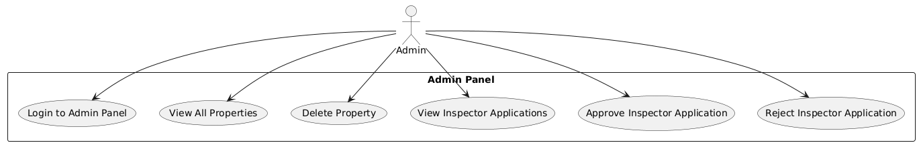

Figure 8 use case for Admin Panel

|  |  |  |
| --- | --- | --- |
| Use Case ID | UC_08 | |
| Use Case Name | Manage Admin Panel | |
| Description | |  | | --- | | This use case describes how an Admin logs into the system, views and manages all listed properties, and handles inspector applications by approving or rejecting them. |  |  | | --- | |  | | |
| Primary Actor | Admin | |
| Secondary Actor | None | |
| Pre-Condition | |  | | --- | |  |  |  | | --- | | - Admin has valid credentials.  - Admin accesses the Admin Panel via login. | | |
| Post-Condition | |  | | --- | |  |  |  | | --- | | Admin manages property data and inspector status, which reflects on the frontend and in user dashboards. | | |
| Basic Flow | Actor Action | System Action |
|  | 1) Admin logs into the Admin Panel using predefined credentials.  2) Admin views all listed properties.  3) Admin can delete any listed property.  4) Admin views all pending inspector applications.  5) Admin either approves or rejects each application. | 1) Validates login credentials.  2) Displays the list of all properties and inspector applications.  3) Deletes selected property from the database and removes it from frontend.  4) Updates inspector status to "Approved" or "Rejected".  5) Notifies inspector of the status upon next login. |
| Alternate Flow | **Actor Action:** Admin deletes an already-removed property.  **System Action:** Displays: "Property not found or already deleted."   **Actor Action:** Admin attempts to approve a malformed or incomplete inspector application.  **System Action:** Displays an error: "Incomplete application — cannot proceed with approval." | |

Table 20 use case for Admin Panel

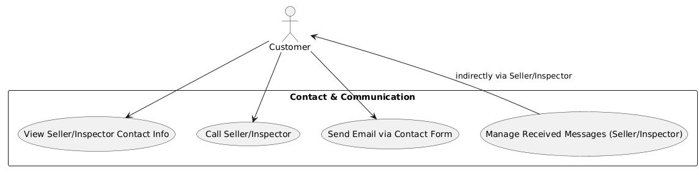

Figure 9 use case for contact & communication

|  |  |  |
| --- | --- | --- |
| Use Case ID | UC_09 | |
| Use Case Name | Contact & Communicate with Seller/Inspector | |
| Description | |  | | --- | |  |  |  | | --- | | This use case describes how a Customer communicates with a Seller or Inspector via contact details or a contact form. Sellers and Inspectors can then manage received inquiries. | | |
| Primary Actor | Customer | |
| Secondary Actor | None | |
| Pre-Condition | - The customer is browsing a property or service listing.  - Seller/Inspector has published valid contact info. | |
| Post-Condition | - Customer successfully contacts seller/inspector via call or form.  - Seller/Inspector receives and can manage the message. | |
| Basic Flow | Actor Action | System Action |
|  | 1) Customer views property or service detail page.  2) Customer sees the Seller/Inspector’s contact number or email.  3) Customer may either:    - Call the number directly.    - Fill out a contact form (name, email, message).  4) Message is sent to the respective Seller or Inspector.  5) Seller/Inspector logs in and views received messages. | 1) Displays relevant contact information on detail pages.  2) Sends email notification or stores form message in the system.  3) Makes the message available to Seller/Inspector in their dashboard. |
| Alternate Flow | **Actor Action:** Customer submits a contact form with missing or invalid fields.  **System Action:** Prompts: “Please fill in all required fields.”  **Actor Action:** Seller/Inspector does not respond.  **System Action:** No direct consequence, message remains marked as “unread” or “pending.” | |

Table 21 use case for Contact & communication

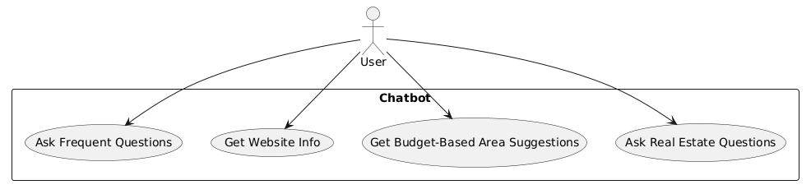

Figure 10 use case for Chatbot

|  |  |  |
| --- | --- | --- |
| Use Case ID | UC_10 | |
| Use Case Name | Interact with Chatbot | |
| Description | This use case describes how a user interacts with the chatbot to ask questions about the website, real estate topics, and receive area suggestions based on their budget. | |
| Primary Actor | User | |
| Secondary Actor | None | |
| Pre-Condition | |  | | --- | |  |  |  | | --- | | - The user is on the website and the chatbot widget is active. | | - The user has a query or needs assistance. | | |
| Post-Condition | |  | | --- | |  |  |  | | --- | | - The user receives helpful answers or guidance. | | - User navigates accordingly or updates their search based on chatbot suggestions. | | |
| Basic Flow | Actor Action | System Action |
|  | 1) User clicks on the chatbot icon.  2) User may ask:    - A frequently asked question (e.g., "How to contact seller?").    - For general website information (e.g., "What is this site about?").    - For area suggestions based on their budget (e.g., "I have 5M budget, where can I buy?").    - Any real estate-related question. | 1) Displays a chatbot interface and processes the user's message.  2) Responds with relevant information using AI or a rule-based engine.  3) May offer links, suggestions, or filtered content based on context (e.g., redirecting to property filters). |
| Alternate Flow | **Actor Action:** User asks a question the chatbot doesn’t understand.  **System Action:** Responds with fallback message: “I’m not sure about that. Please try rephrasing or contact support.” | |

Table 22 use case for Chatbot

# Chapter 4: Design

In this section, we provide the design analysis of our modules including the following designs

1. Architecture Diagram
2. ERD with data dictionary
3. Data Flow diagram
4. Class Diagram
5. Activity Diagram
6. Sequence Diagram
7. Collaboration Diagram
8. State Transition Diagram
9. Component Diagram
10. Deployment Diagram

#### Architecture Diagram

Define the graphical representation of the concepts, their principles, elements and components that are part of your project.

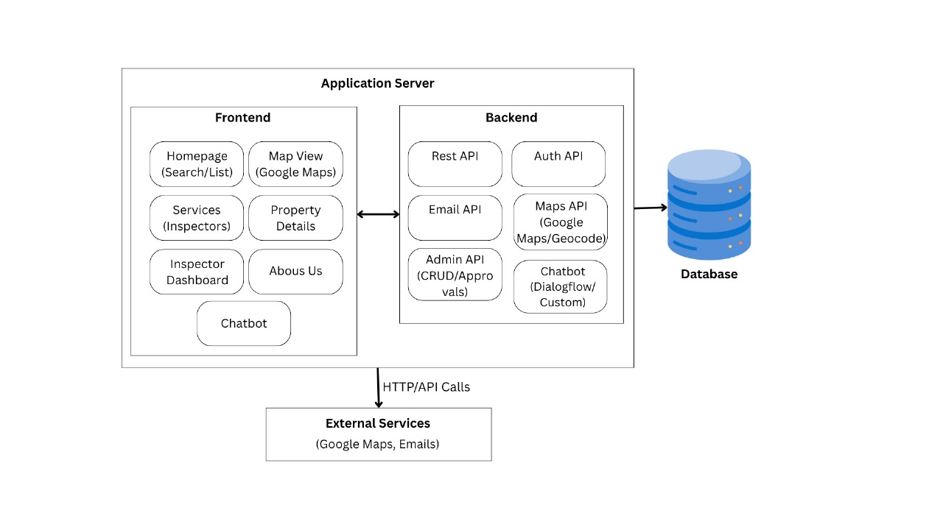

Figure 11 Architecture Diageam

#### ERD with data dictionary

EntityRelationshipDiagram with complete relations with dependencies of your project

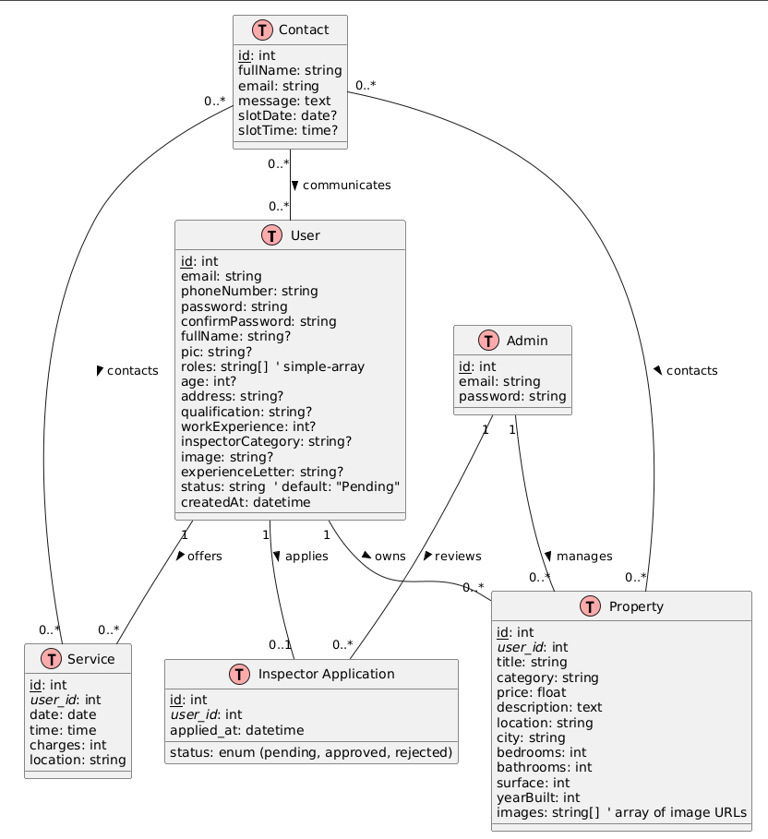

Figure 12 ERD

#### Data Flow diagram

Data flow diagram includes two levels

###### The level 0

The flow of information inside the system is defined in this level

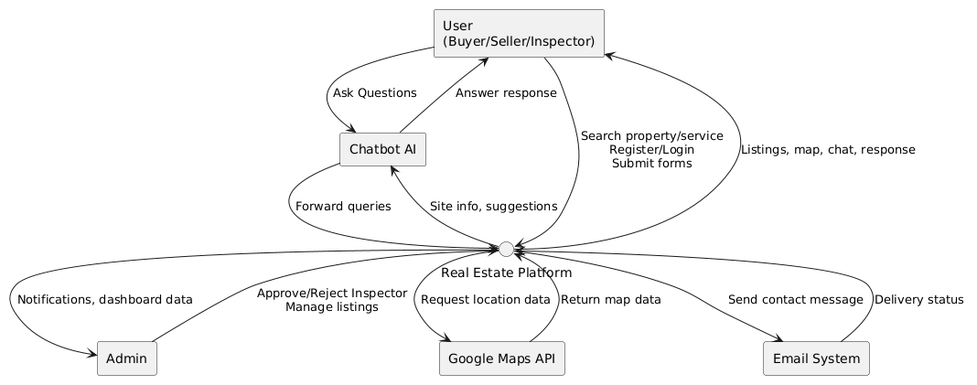

Figure 13 Level 0 DFD

###### The level 1

The flow of information outside the system is defined in this level

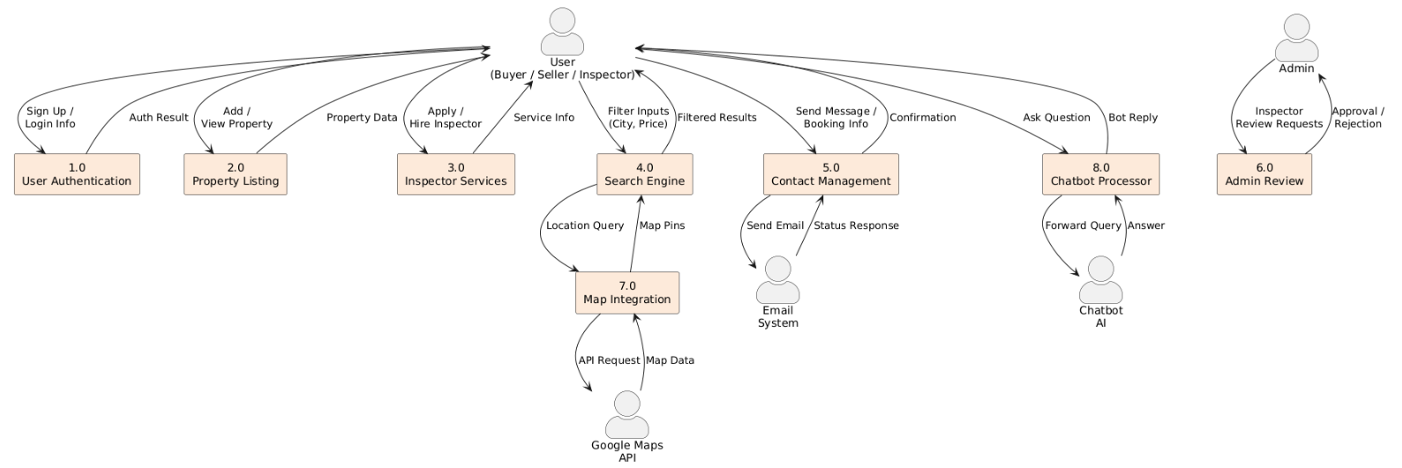

Figure 14 Level 1 DFD

#### Class Diagram

Describe the structure of a project by showing the systems classes, their attributes, operations (or methods), and the relationships among objects.

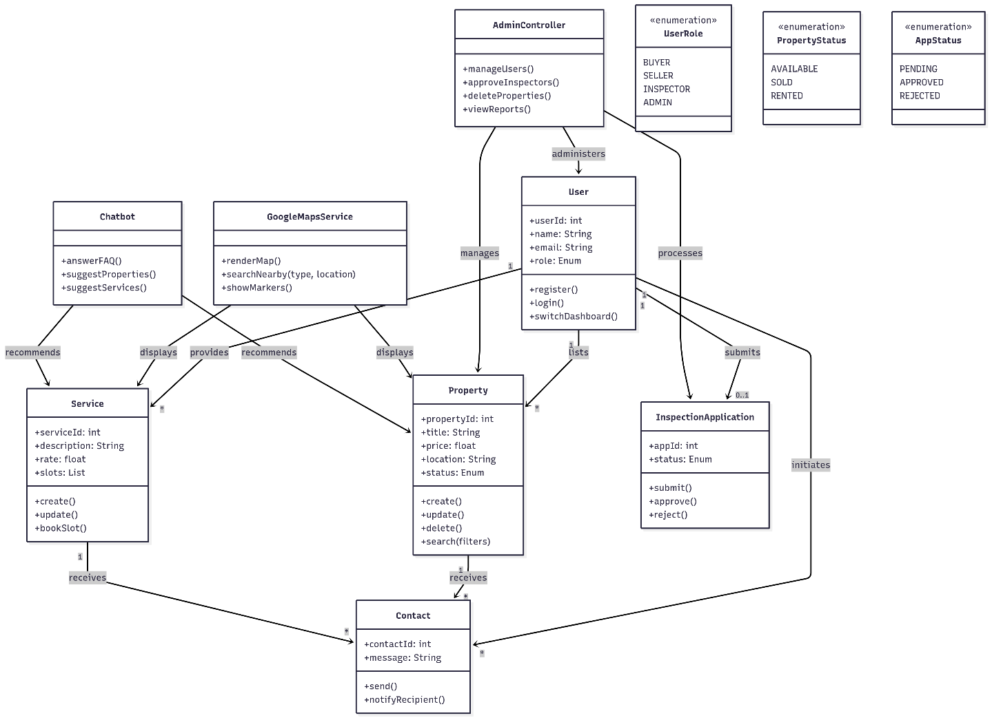

Figure 15 Class Diagram

#### Activity Diagram

This diagram includes all the activity diagrams of the functional requirements of your project along with the aggregated activity diagram

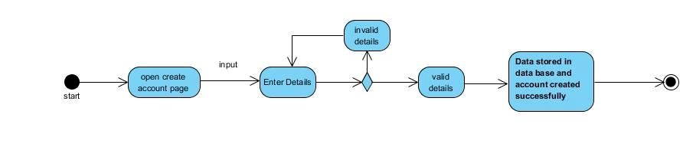

Figure 16 Activity Diagram Create Account

#### Sequence Diagram

This diagram includes all the Sequence diagrams of the functional requirements of your project along with the aggregated Sequence diagram

The Sequence diagrams can be made by using Visual Paradigm

1. Select **Diagram > New** from the application toolbar.
2. In the **New Diagram** window, select **Sequence** **Diagram**.
3. Click **Next**.
4. Enter the diagram name and description.
5. Click **OK**.

For example, yours create account Sequence look like this and you have to follow this template for writing your Sequence diagrams

Sequence diagram for create account

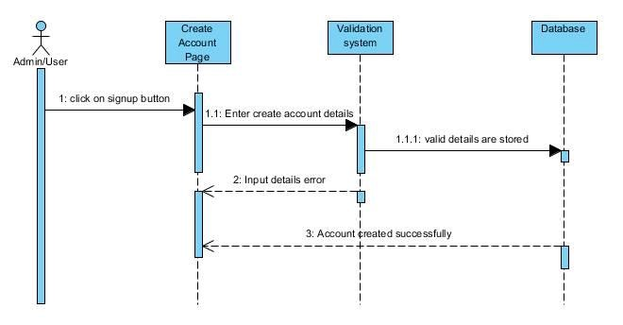

Figure 17 Sequence Diagram Create Account

#### Collaboration Diagram

It shows the object organization as shown below. Here in collaboration diagram the method call sequence is indicated by some numbering technique as shown below. The number indicates how the methods are called one after another. We have taken the same order management system to describe the collaboration diagram.

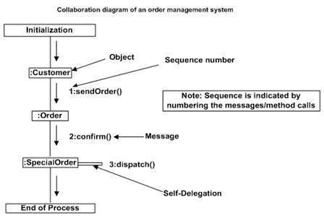

Figure 18 Collaboration Diagram

#### State Transition Diagram

State Transition diagram is used to describe the states of different objects in its life cycle. So, the emphasis is given on the state changes upon some internal or external events. These states of objects are important to analyze and implement them accurately

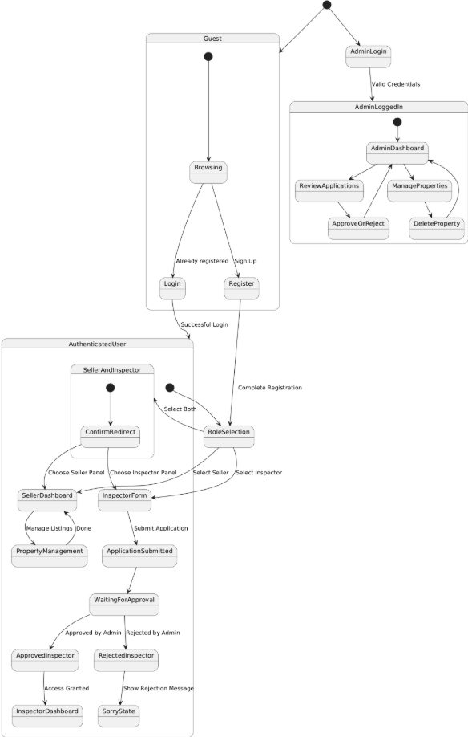

Figure 19 State Transition Diagram

#### Component Diagram

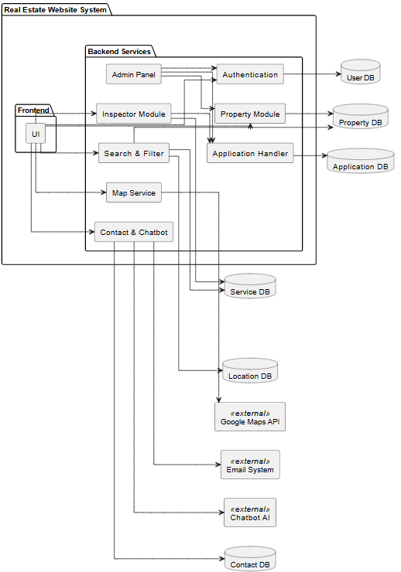

Figure 20 Component Diagram

#### Deployment Diagram

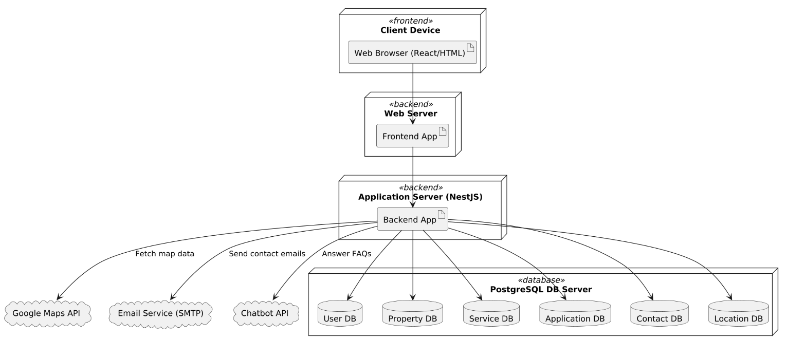

Figure 21 Deployment Diagram

# Chapter 5: Testing

#### Test Case Specifications

Test Case – User Registration (Positive)

| **Field** | **Detail** |
| --- | --- |
| ID | TC_USER_REGISTER_SUCCESS |
| Priority | High |
| Description | To verify successful registration as seller, inspector, or both. |
| Reference | FR_01: Create Account |
| Users | Buyers, Sellers, Inspectors |
| Pre-requisites | User must have internet access |
| Steps | Open registration form > Fill details > Select role(s) > Submit |
| Input | Name, email, password, phone, role selection |
| Expected Result | Account created and user redirected to relevant dashboard |
| Status | Tested, Passed |

Table 23 User Registration Positive

Test Case – User Registration (Negative)

| **Field** | **Detail** |
| --- | --- |
| ID | TC_USER_REGISTER_FAIL |
| Priority | High |
| Description | To verify registration fails with incomplete or invalid info. |
| Reference | FR_01: Create Account |
| Users | Buyers, Sellers, Inspectors |
| Pre-requisites | System online |
| Steps | Open form > Submit with invalid email or missing password |
| Input | Incomplete/invalid registration data |
| Expected Result | Error message shown, account not created |
| Status | Tested, Passed |

Table 24 User Registeration Negative

Test Case – User Login (Positive)

| **Field** | **Detail** |
| --- | --- |
| ID | TC_USER_LOGIN_SUCCESS |
| Priority | High |
| Description | To verify login success with valid credentials |
| Reference | FR_02: Login Account |
| Users | All registered users |
| Pre-requisites | User account must exist |
| Steps | Open login page > Enter credentials > Submit |
| Input | Email and password |
| Expected Result | Redirected to respective dashboard |
| Status | Tested, Passed |

Table 25 User Login Positive

Test Case – User Login (Negative)

| **Field** | **Detail** |
| --- | --- |
| ID | TC_USER_LOGIN_FAIL |
| Priority | High |
| Description | To verify login fails with incorrect credentials |
| Reference | FR_02: Login Account |
| Users | All registered users |
| Pre-requisites | System online |
| Steps | Open login page > Enter wrong credentials > Submit |
| Input | Wrong email or password |
| Expected Result | Error shown, login denied |
| Status | Tested, Passed |

Table 26 User Login Negative

Test Case – Property Add by Seller (Positive)

| **Field** | **Detail** |
| --- | --- |
| ID | TC_ADD_PROPERTY_SUCCESS |
| Priority | High |
| Description | Verify property is added successfully by seller |
| Reference | FR_04: Add Property |
| Users | Seller |
| Pre-requisites | Seller logged in |
| Steps | Open dashboard > Fill form > Submit |
| Input | Property title, location, type, price, images |
| Expected Result | Property listed on frontend |
| Status | Tested, Passed |

Table 27 Property Add By Seller Positive

Test Case – Property Add by Seller (Negative)

| **Field** | **Detail** |
| --- | --- |
| ID | TC_ADD_PROPERTY_FAIL |
| Priority | High |
| Description | Ensure system blocks invalid property submissions |
| Reference | FR_04: Add Property |
| Users | Seller |
| Pre-requisites | System online |
| Steps | Fill form with empty fields or wrong data > Submit |
| Input | Missing title/price/location |
| Expected Result | Error message, property not added |
| Status | Tested, Passed |

Table 28 Property Add By Seller Negative

Test Case – Inspector Application Submission (Positive)

| **Field** | **Detail** |
| --- | --- |
| ID | TC_INSPECTOR_APP_SUBMIT_SUCCESS |
| Priority | High |
| Description | To verify successful inspector application submission |
| Reference | FR_06: Submit Inspector Application |
| Users | Inspector |
| Pre-requisites | Inspector logged in |
| Steps | Open application form > Fill fields > Upload docs > Submit |
| Input | Experience, image, service type |
| Expected Result | Application sent to admin |
| Status | Tested, Passed |

Table 29 Inspector Application Submission Positive

Test Case – Inspector Application Submission (Negative)

| **Field** | **Detail** |
| --- | --- |
| ID | TC_INSPECTOR_APP_SUBMIT_FAIL |
| Priority | High |
| Description | Ensure invalid application is not submitted |
| Reference | FR_06: Submit Inspector Application |
| Users | Inspector |
| Pre-requisites | System online |
| Steps | Leave mandatory fields empty > Submit |
| Input | Missing experience or image |
| Expected Result | Error message, application rejected |
| Status | Tested, Passed |

Table 30 Inspector Application Submission Negative

Test Case – Admin Inspector Approval (Positive)

| **Field** | **Detail** |
| --- | --- |
| ID | TC_ADMIN_INSPECTOR_APPROVE_SUCCESS |
| Priority | High |
| Description | To verify admin approves valid inspector |
| Reference | FR_07: Approve/Reject Inspector |
| Users | Admin |
| Pre-requisites | Inspector application submitted |
| Steps | Admin opens panel > Approves application |
| Input | Inspector ID |
| Expected Result | Inspector can access dashboard |
| Status | Tested, Passed |

Table 31 Admin Inspector Approval (Positive)

Test Case – Admin Inspector Approval (Negative)

| **Field** | **Detail** |
| --- | --- |
| ID | TC_ADMIN_INSPECTOR_APPROVE_FAIL |
| Priority | High |
| Description | Verify rejection disables inspector access |
| Reference | FR_07: Approve/Reject Inspector |
| Users | Admin |
| Pre-requisites | Inspector application submitted |
| Steps | Admin opens panel > Rejects application |
| Input | Inspector ID |
| Expected Result | Inspector sees rejection message at login |
| Status | Tested, Passed |

Table 32 Admin Inspector Approval (Negative)

Test Case – Service CRUD by Inspector (Positive)

| **Field** | **Detail** |
| --- | --- |
| ID | TC_INSPECTOR_SERVICE_CRUD_SUCCESS |
| Priority | Medium |
| Description | To verify inspectors can add/update/delete their services |
| Reference | FR_08: Inspector Service Add/Delete/Update |
| Users | Inspector |
| Pre-requisites | Inspector must be approved |
| Steps | Login > Open dashboard > Manage services |
| Input | Service title, slot, location |
| Expected Result | Services listed on frontend |
| Status | Tested, Passed |

Table 33 Service CRUD by Inspector (Positive)

Test Case – Service CRUD by Inspector (Negative)

| **Field** | **Detail** |
| --- | --- |
| ID | TC_INSPECTOR_SERVICE_CRUD_FAIL |
| Priority | Medium |
| Description | Ensure invalid services are not saved |
| Reference | FR_08: Inspector Service Add/Delete/Update |
| Users | Inspector |
| Pre-requisites | Inspector must be approved |
| Steps | Submit service form with missing data |
| Input | Empty title or invalid slot |
| Expected Result | Error shown, service not listed |
| Status | Tested, Passed |

Table 34 Service CRUD by Inspector (Negative)

Test Case – Chatbot Query (Positive)

| **Field** | **Detail** |
| --- | --- |
| ID | TC_CHATBOT_QUERY_SUCCESS |
| Priority | Medium |
| Description | To verify chatbot responds to budget query |
| Reference | FR_11: Use Chatbot |
| Users | Buyer |
| Pre-requisites | Chatbot API (OpenAI) online |
| Steps | Enter "Suggest areas under 50 lacs" |
| Input | Natural language query |
| Expected Result | AI-generated suggestion displayed |
| Status | Tested, Passed |

Table 35 Chatbot Query (Positive)

Test Case – Chatbot Query (Negative)

| **Field** | **Detail** |
| --- | --- |
| ID | TC_CHATBOT_QUERY_FAIL |
| Priority | Medium |
| Description | Verify chatbot handles unknown queries gracefully |
| Reference | FR_11: Use Chatbot |
| Users | Buyer |
| Pre-requisites | Chatbot API online |
| Steps | Enter unclear/unsupported query |
| Input | Gibberish or undefined terms |
| Expected Result | Graceful fallback message displayed |
| Status | Tested, Passed |

Table 36 Chatbot Query (Negative)

#### Black Box Test Cases

Test Case – Search Property Listings

|  |  |
| --- | --- |
| **Field** | **Detail** |
| ID | BB_TC_PROPERTY_SEARCH_SUCCESS |
| Priority | High |
| Description | To validate property listings load based on search filters |
| Reference | FR_09: Property/Inspector Search |
| Users | Buyer |
| Pre-requisites | Properties must be listed in database |
| Steps | Enter filters > Submit |
| Input | City: Lahore, Price Range: 30-50 lac |
| Expected Result | List of matching properties is displayed |
| Status | Tested, Passed |

Table 37 Search Property Listings

Test Case – Invalid Property Search Filters

|  |  |
| --- | --- |
| Field | Detail |
| ID | BB_TC_PROPERTY_SEARCH_FAIL |
| Priority | Medium |
| Description | To verify system handles invalid/empty search filters |
| Reference | FR_09: Property/Inspector Search |
| Users | Buyer |
| Pre-requisites | System online |
| Steps | Submit with empty/invalid fields |
| Input | City: --- , Price: -1 |
| Expected Result | Warning message or no results displayed |
| Status | Tested, Passed |

Table 38 Invalid Property Search Filters

Test Case – Inspector Booking from Map

|  |  |
| --- | --- |
| Field | Detail |
| ID | BB_TC_BOOK_INSPECTOR_MAP |
| Priority | Medium |
| Description | To validate inspector details display when clicked on map |
| Reference | FR_10: Map View |
| Users | Buyer |
| Pre-requisites | Approved inspector with mapped location |
| Steps | Open map > Click inspector pin |
| Input | City = Karachi |
| Expected Result | Inspector details and booking option visible |
| Status | Tested, Passed |

Table 39 Inspector Booking from Map

Test Case – Contact via Email to Seller/Inspector

|  |  |
| --- | --- |
| Field | Detail |
| ID | BB_TC_CONTACT_EMAIL |
| Priority | Medium |
| Description | To verify user can send email from contact form |
| Reference | Contact Module |
| Users | Buyer |
| Pre-requisites | Seller/Inspector email present |
| Steps | Open listing > Click contact > Fill form > Send |
| Input | Name, Email, Message |
| Expected Result | Confirmation message after send |
| Status | Tested, Passed |

Table 40 Contact via Email to Seller/Inspector

Test Case – Chatbot Real Estate Advice

|  |  |
| --- | --- |
| Field | Detail |
| ID | BB_TC_CHATBOT_ADVICE |
| Priority | Medium |
| Description | Verify chatbot gives accurate area suggestions |
| Reference | FR_11: Use Chatbot |
| Users | Buyer |
| Pre-requisites | Chatbot API active |
| Steps | Enter budget-based query |
| Input | "Best area under 40 lac in Islamabad?" |
| Expected Result | Relevant areas listed |
| Status | Tested, Passed |

Table 41 Chatbot Real Estate Advice

Test Case – Chatbot Invalid Input Handling

|  |  |
| --- | --- |
| Field | Detail |
| ID | BB_TC_CHATBOT_INVALID_INPUT |
| Priority | Low |
| Description | Ensure chatbot responds gracefully to nonsensical input |
| Reference | FR_11: Use Chatbot |
| Users | All users |
| Pre-requisites | Chatbot API online |
| Steps | Enter gibberish query |
| Input | "asdfgh123$%" |
| Expected Result | Message like "Sorry, I didn't understand that" shown |
| Status | Tested, Passed |

Table 42 Chatbot Invalid Input Handling

* + 1. Equivalence Partitions (EP)

Equivalence Partitioning (EP) is a black-box testing technique that divides input data of a software unit into partitions of valid and invalid classes. Each partition represents a set of valid or invalid states for testing to minimize the number of test cases while maintaining coverage.

EP Table – User Registration

|  |  |  |
| --- | --- | --- |
| **Variables** | **Valid Classes** | **Invalid Classes** |
| Email | Proper format (abc@example.com) | Empty / invalid format (abc@, @mail, etc.) |
| Password | 8+ characters, includes letters & digits | Less than 8 characters, only letters or digits |
| Role Selection | Seller, Inspector, Both | No role selected |

Table 43 EP Table – User Registration

EP Table – Property Search

|  |  |  |
| --- | --- | --- |
| Variables | Valid Classes | Invalid Classes |
| City | Existing cities (e.g., Lahore, Karachi) | Non-existent or blank |
| Price Range | Positive numeric range (10–90 lac) | Negative values, characters (e.g., "abc") |
| Property Type | Rent, Buy | Null / invalid entry |

Table 44 EP Table – Property Search

EP Table – Inspector Application Submission

|  |  |  |
| --- | --- | --- |
| Variables | Valid Classes | Invalid Classes |
| Experience Field | Textual data, relevant description | Blank / numeric only |
| Document Upload | Image/pdf format accepted | Missing / unsupported file format |
| Service Type | Valid category selected | None selected |

Table 45 EP Table – Inspector Application Submission

EP Table – Admin Approval Process

|  |  |  |
| --- | --- | --- |
| Variables | Valid Classes | Invalid Classes |
| Application Status | Approved, Rejected | Empty / invalid enum |
| Inspector ID | Existing inspector ID | Null / non-existent ID |

Table 46 EP Table – Admin Approval Process

EP Table – Service CRUD by Inspector

|  |  |  |
| --- | --- | --- |
| Variables | Valid Classes | Invalid Classes |
| Title | Descriptive string | Empty |
| Slot Timings | Valid time ranges (e.g., 10AM - 12PM) | Overlapping/invalid format |
| Location | Mapped, verified city names | Null/unsupported string |

Table 47 EP Table – Service CRUD by Inspector

EP Table – Chatbot Queries

|  |  |  |
| --- | --- | --- |
| Variables | Valid Classes | Invalid Classes |
| User Input | Real estate-related queries | Gibberish, unsupported characters |
| Budget Format | Numeric range + location | Missing budget or ambiguous question |

Table 48 EP Table – Chatbot Queries

* + 1. Boundary Value Analysis

Boundary Value Analysis is a technique in which test cases are designed to include values at the boundaries. This is because boundaries are where most errors tend to occur. We test just below, at, and just above the edge of input ranges.

BVA Table – Password Length Validation (User Registration)

|  |  |  |
| --- | --- | --- |
| **Test Case ID** | **Input Length** | **Expected Result** |
| BVA_PASS_TC_01 | 7 | Rejected (below min length) |
| BVA_PASS_TC_02 | 8 | Accepted (minimum valid) |
| BVA_PASS_TC_03 | 20 | Accepted (maximum valid) |
| BVA_PASS_TC_04 | 21 | Rejected (above max length) |

Table 49 BVA Table – Password Length Validation (User Registration)

BVA Table – Property Price Range Filter

|  |  |  |
| --- | --- | --- |
| Test Case ID | Input Value (Lac) | Expected Result |
| BVA_PRICE_TC_01 | -1 | Rejected (negative value) |
| BVA_PRICE_TC_02 | 0 | Accepted |
| BVA_PRICE_TC_03 | 10 | Accepted (valid low) |
| BVA_PRICE_TC_04 | 90 | Accepted (valid high) |
| BVA_PRICE_TC_05 | 91 | Rejected (above expected max) |

Table 50 BVA Table – Property Price Range Filter

BVA Table – Slot Time Range (Inspector Service)

|  |  |  |
| --- | --- | --- |
| Test Case ID | Input Time | Expected Result |
| BVA_SLOT_TC_01 | 09:59 | Rejected (before valid slot) |
| BVA_SLOT_TC_02 | 10:00 | Accepted (slot start boundary) |
| BVA_SLOT_TC_03 | 18:00 | Accepted (slot end boundary) |
| BVA_SLOT_TC_04 | 18:01 | Rejected (after valid slot) |

Table 51 BVA Table – Slot Time Range (Inspector Service)

BVA Table – Inspector Experience Years

|  |  |  |
| --- | --- | --- |
| Test Case ID | Input Years | Expected Result |
| BVA_EXP_TC_01 | -1 | Rejected (invalid negative) |
| BVA_EXP_TC_02 | 0 | Accepted (fresh entry) |
| BVA_EXP_TC_03 | 30 | Accepted (valid upper bound) |
| BVA_EXP_TC_04 | 31 | Rejected (exceeds limit) |

Table 52 BVA Table – Inspector Experience Years

BVA Table – Email Input Characters

|  |  |  |
| --- | --- | --- |
| Test Case ID | Input Length | Expected Result |
| BVA_EMAIL_TC_01 | 0 | Rejected (empty) |
| BVA_EMAIL_TC_02 | 1 | Rejected (incomplete format) |
| BVA_EMAIL_TC_03 | 5 | Rejected (still likely invalid) |
| BVA_EMAIL_TC_04 | 12 | Accepted (typical email length) |

Table 53 BVA Table – Email Input Characters

* + 1. Decision Table Testing

Decision Table Testing is a black-box test design technique used for modeling complex logic and business rules. Each decision table lists combinations of conditions and the corresponding system actions.

Decision Table – User Role Redirection After Login

|  |  |  |  |
| --- | --- | --- | --- |
| **Test Case** | **Seller Selected** | **Inspector Selected** | **Expected Redirect Page** |
| DT_ROLE_01 | Yes | No | Seller Dashboard |
| DT_ROLE_02 | No | Yes | Inspector Dashboard |
| DT_ROLE_03 | Yes | Yes | Prompt for panel choice |
| DT_ROLE_04 | No | No | Error / Prompt to select |

Table 54 Decision Table – User Role Redirection After Login

Decision Table – Property Search Filter Logic

|  |  |  |  |  |
| --- | --- | --- | --- | --- |
| Test Case | City Provided | Price Range Valid | Type Selected | Result Type |
| DT_SEARCH_01 | Yes | Yes | Yes | Show matching listings |
| DT_SEARCH_02 | Yes | No | Yes | Prompt invalid price |
| DT_SEARCH_03 | No | Yes | Yes | Prompt city required |
| DT_SEARCH_04 | Yes | Yes | No | Prompt type required |

Table 55 Decision Table – Property Search Filter Logic

Decision Table – Inspector Application Review (Admin)

|  |  |  |  |  |
| --- | --- | --- | --- | --- |
| Test Case | Inspector Submitted | Documents Valid | Admin Action | System Output |
| DT_ADMIN_01 | Yes | Yes | Approve | Inspector gets dashboard access |
| DT_ADMIN_02 | Yes | Yes | Reject | Display rejection message |
| DT_ADMIN_03 | Yes | No | Reject | Notify missing documents |
| DT_ADMIN_04 | No | -- | -- | No action taken |

Table 56 Decision Table – Inspector Application Review (Admin)

Decision Table – Chatbot Response Scenarios

|  |  |  |  |
| --- | --- | --- | --- |
| Test Case | Budget Mentioned | Location Mentioned | Expected Chatbot Output |
| DT_CHAT_01 | Yes | Yes | Suggest properties/areas |
| DT_CHAT_02 | Yes | No | Ask for location |
| DT_CHAT_03 | No | Yes | Ask for budget |
| DT_CHAT_04 | No | No | Ask for both |

Table 57 Decision Table – Chatbot Response Scenarios

Decision Table – Inspector Service CRUD Validations

|  |  |  |  |  |
| --- | --- | --- | --- | --- |
| Test Case | Title Given | Slot Valid | Location Selected | Save Operation Result |
| DT_SERVICE_01 | Yes | Yes | Yes | Service saved successfully |
| DT_SERVICE_02 | No | Yes | Yes | Prompt title is required |
| DT_SERVICE_03 | Yes | No | Yes | Prompt invalid time slot |
| DT_SERVICE_04 | Yes | Yes | No | Prompt location required |

Table 58 Decision Table – Inspector Service CRUD Validations

* + 1. State transition Testing

State Transition Testing is used to validate the behavior of the system when it moves from one state to another based on user actions or internal triggers. This is especially useful for modules involving login flows, registration, role selection, and dashboard redirections.

State Transition Table – User Registration Flow

|  |  |  |  |
| --- | --- | --- | --- |
| **Current State** | **Event** | **Next State** | **Expected Action** |
| Start | Open Registration Page | Filling Form | Show registration form |
| Filling Form | Submit Valid Data | Role Selection | Ask to select role(s) |
| Role Selection | One Role Selected | Redirecting | Redirect to selected panel |
| Role Selection | Both Roles Selected | Confirmation Prompt | Ask for redirection choice |
| Redirecting | Panel Loaded | Dashboard Access | Show appropriate dashboard |

Table 59 State Transition Table – User Registration Flow

State Transition Table – Inspector Application Review

|  |  |  |  |
| --- | --- | --- | --- |
| Current State | Event | Next State | Expected Action |
| Submitted | Admin Opens Panel | Reviewing | Show application details |
| Reviewing | Admin Clicks Approve | Approved | Grant inspector access |
| Reviewing | Admin Clicks Reject | Rejected | Show rejection message |
| Approved | Inspector Logs In | Inspector Panel | Enable service CRUD |
| Rejected | Inspector Logs In | Blocked | Show rejection alert |

Table 60 State Transition Table – Inspector Application Review

State Transition Table – Property Posting by Seller

|  |  |  |  |
| --- | --- | --- | --- |
| Current State | Event | Next State | Expected Action |
| Seller Login | Click Add Property | Fill Form | Open property form |
| Fill Form | Submit Valid Details | Pending Listing | Property sent to database |
| Pending Listing | Auto Update | Published | Property visible on frontend |
| Fill Form | Submit Invalid Details | Error | Show validation errors |

Table 61 State Transition Table – Property Posting by Seller

State Transition Table – Chatbot Session Handling

|  |  |  |  |
| --- | --- | --- | --- |
| Current State | Event | Next State | Expected Action |
| Idle | User Opens Chatbot | Listening | Prompt welcome message |
| Listening | Budget & Location Input | Processing Query | Analyze input |
| Processing Query | Valid Query | Responding | Show area/property suggestions |
| Processing Query | Invalid/Nonsense Input | Error State | Respond with fallback/help message |

Table 62 State Transition Table – Chatbot Session Handling

State Transition Table – Login & Role-Based Dashboard Routing

|  |  |  |  |
| --- | --- | --- | --- |
| Current State | Event | Next State | Expected Action |
| Login Page | Enter Credentials | Authenticating | Validate email/password |
| Authenticating | Valid Credentials | Check Role | Redirect based on role(s) |
| Check Role | Seller Only | Seller Dashboard | Show seller tools |
| Check Role | Inspector Only | Inspector Dashboard | Show inspector tools |
| Check Role | Both Selected | Prompt Choice | Ask for preferred panel |
| Authenticating | Invalid Credentials | Login Failed | Show error message |

Table 63 State Transition Table – Login & Role-Based Dashboard Routing

* + 1. Use Case Testing

#### **Use Case: UC_01 – Create Account**

**Use Case Name:** Create Account  
**Actors:** User (Buyer, Seller, Inspector)  
**Preconditions:**

* User must have internet access
* User must be on Sign-Up page

**Basic Flow:**

1. User enters name, email, password, phone
2. Selects roles (Seller, Inspector, or Both)
3. Clicks “Sign Up”
4. System creates account
5. If both roles selected, prompt for redirection options

**Alternative Flows:**  
A1. Missing/invalid inputs → Error message shown  
A2. Existing email → System denies registration

**Postconditions:**  
Account created and stored in DB, redirected to selected dashboard

**Expected Result:**  
User account successfully registered and redirected

#### **Use Case: UC_02 – Add Property (Seller Panel)**

**Use Case Name:** Add Property  
**Actors:** Seller

**Preconditions:**

* Seller logged in
* Access to Seller Dashboard

**Basic Flow:**

1. Seller fills property form (title, location, type, price)
2. Clicks “Submit”
3. System validates and stores data
4. Property listed on frontend

**Alternative Flows:**  
A1. Invalid data → System prompts for correction

**Postconditions:**  
Property listed and visible to users

**Expected Result:**  
Property successfully added to the system

#### **Use Case: UC_03 – Submit Inspector Application**

**Use Case Name:** Submit Inspector Application  
**Actors:** Inspector  
**Preconditions:**

* Inspector registered
* Inspector selects Inspector Panel

**Basic Flow:**

1. Inspector opens application form
2. Fills details, uploads experience
3. Clicks submit
4. System sends request to Admin

**Alternative Flows:**  
A1. Missing fields → Form not submitted

**Postconditions:**  
Application sent to Admin for approval

**Expected Result:**  
Application stored and visible to Admin

#### **Use Case: UC_04 – Approve/Reject Inspector (Admin)**

**Use Case Name:** Approve/Reject Inspector  
**Actors:** Admin  
**Preconditions:**

* Admin logged in
* Application list available

**Basic Flow:**

1. Admin views pending applications
2. Selects application
3. Clicks Approve/Reject
4. Status updated in system

**Alternative Flows:**  
A1. Network error → Action not processed

**Postconditions:**  
Inspector receives approval or rejection response

**Expected Result:**  
System updates inspector status accordingly

#### **Use Case: UC_05 – Search Property/Service**

**Use Case Name:** Search Property/Service  
**Actors:** User (Buyer)  
**Preconditions:**

* User is on Home/Services/Map page

**Basic Flow:**

1. User enters filters (city, location, price, buy/rent)
2. Clicks search
3. System fetches filtered results
4. Results displayed to user

**Alternative Flows:**  
A1. No results match → “No properties found” message shown

**Postconditions:**  
User views property or inspection listings

**Expected Result:**  
Accurate filtered data is shown to the user

#### **Use Case: UC_06 – Contact Seller or Inspector**

**Use Case Name:** Contact Seller or Inspector  
**Actors:** User (Buyer)  
**Preconditions:**

* Property or service listing available
* Contact details enabled

**Basic Flow:**

1. User clicks on property or service
2. Contact info (phone/email) displayed
3. User fills contact form or calls directly

**Alternative Flows:**  
A1. Email fails to send → System shows failure notice

**Postconditions:**  
Message sent or contact made with Seller/Inspector

**Expected Result:**  
User successfully initiates contact

#### **Use Case: UC_07 – Use AI Chatbot**

**Use Case Name:** Use AI Chatbot  
**Actors:** Any site visitor  
**Preconditions:**

* Chatbot widget loaded on website

**Basic Flow:**

1. User opens chatbot
2. Asks a question (e.g. "suggest area in budget")
3. Chatbot processes query
4. Displays relevant answer

**Alternative Flows:**  
A1. API failure → Error or fallback message shown

**Postconditions:**  
User receives chatbot assistance

**Expected Result:**  
Chatbot responds with accurate, relevant information

#### White Box Test Cases

White Box Testing focuses on the internal logic, code paths, and structure of the application. This section outlines key function-level test cases that verify the correctness of individual components of the **Prime Innovative Hub** system.

#### **Test Case 1 – Function: Register User()**

| **Field** | **Detail** |
| --- | --- |
| **ID** | WB_TC_01 |
| **Function** | Register User() |
| **Purpose** | Validate user registration based on role selection |
| **Test Type** | Condition Coverage |
| **Input** | Name, Email, Password, Role (Seller/Inspector/Both) |
| **Expected Output** | User created and redirected to relevant dashboard |
| **Branches Tested** | If role == Seller / Inspector / Both |
| **Status** | Passed |

Table 64 Test Case 1 – Function: Register User()

#### **Test Case 2 – Function: Submit Inspector Application**

| **Field** | **Detail** |
| --- | --- |
| **ID** | WB_TC_02 |
| **Function** | submitInspectorApplication() |
| **Purpose** | Ensure inspector application is stored and sent to Admin |
| **Test Type** | Decision Coverage |
| **Input** | Inspector name, experience, file upload |
| **Expected Output** | Application saved, success message shown |
| **Branches Tested** | Valid input → Store application; Invalid → Return error |
| **Status** | Passed |

Table 65 Test Case 2 – Function: Submit Inspector Application

#### **Test Case 3 – Function: Approve Or Reject Inspector()**

| **Field** | **Detail** |
| --- | --- |
| **ID** | WB_TC_03 |
| **Function** | approveOrRejectInspector(inspectorID, decision) |
| **Purpose** | Ensure Admin can approve or reject applications |
| **Test Type** | Path Coverage |
| **Input** | Inspector ID, decision = approve or reject |
| **Expected Output** | Inspector status updated; notification sent |
| **Paths Tested** | If decision = approve → Set status approved; else → Set rejected |
| **Status** | Passed |

Table 66 Test Case 3 – Function: Approve Or Reject Inspector()

#### **Test Case 4 – Function: AddProperty()**

| **Field** | **Detail** |
| --- | --- |
| **ID** | WB_TC_04 |
| **Function** | addProperty() |
| **Purpose** | Validate property listing creation |
| **Test Type** | Multiple Condition Coverage |
| **Input** | Property title, location, price, images |
| **Expected Output** | Property saved, shown on frontend |
| **Conditions Tested** | All fields filled → Save; Missing fields → Return error |
| **Status** | Passed |

Table 67 Test Case 4 – Function: AddProperty()

#### **Test Case 5 – Function: filterProperties()**

| **Field** | **Detail** |
| --- | --- |
| **ID** | WB_TC_05 |
| **Function** | filterProperties(filters) |
| **Purpose** | Test accurate filtering of property listings |
| **Test Type** | Statement and Loop Coverage |
| **Input** | Filters: city = Lahore, price = 30–50 lac |
| **Expected Output** | Filtered list of properties |
| **Loop Tested** | For each property → Apply all filters |
| **Status** | Passed |

Table 68 Test Case 5 – Function: filterProperties()

#### **Test Case 6 – Function: ChatbotRespond()**

| **Field** | **Detail** |
| --- | --- |
| **ID** | WB_TC_06 |
| **Function** | chatbotRespond(query) |
| **Purpose** | Verify chatbot sends query to API and displays result |
| **Test Type** | API Integration & Condition Coverage |
| **Input** | "Suggest area for 40 lac in Karachi" |
| **Expected Output** | Relevant response from OpenAI API |
| **Branches Tested** | If API success → Show response; else → Show fallback message |
| **Status** | Passed |

Table 69 Test Case 6 – Function: ChatbotRespond()

* + 1. Cyclometric complexity

Cyclomatic Complexity is a metric used to measure the complexity of a program's control flow. It helps determine the number of independent paths through the program and guides the creation of effective test cases.

The formula used is:  
**CC = E − N + 2P**  
Where:

* **E** = Number of edges
* **N** = Number of nodes
* **P** = Number of connected components (usually 1 for a single function)

#### **Function: registerUser()**

**Code Summary:**

javascript

CopyEdit

function registerUser(role) {

if (role === "Seller") {

redirectToSellerDashboard();

} else if (role === "Inspector") {

redirectToInspectorDashboard();

} else if (role === "Both") {

promptForDashboardChoice();

} else {

showError("Invalid role selected");

}

}

* Nodes (N): 6
* Edges (E): 7
* P: 1
* **Cyclomatic Complexity: CC = 7 − 6 + 2(1) = 3**

#### **Function: approveOrRejectInspector()**

**Code Summary:**

typescript

CopyEdit

function approveOrRejectInspector(id, action) {

if (action === "approve") {

updateStatus(id, "Approved");

} else if (action === "reject") {

updateStatus(id, "Rejected");

} else {

throw new Error("Invalid action");

}

}

* Nodes (N): 5
* Edges (E): 6
* P: 1
* **Cyclomatic Complexity: CC = 6 − 5 + 2 = 3**

#### **Function: filterProperties()**

**Code Summary:**

typescript

CopyEdit

function filterProperties(properties, filters) {

const results = [];

for (let p of properties) {

if (matches(p, filters)) {

results.push(p);

}

}

return results;

}

* Nodes (N): 4
* Edges (E): 5
* P: 1
* **Cyclomatic Complexity: CC = 5 − 4 + 2 = 3**

#### **Function: chatbotRespond()**

**Code Summary:**

javascript

CopyEdit

function chatbotRespond(query) {

if (!query) {

return "Please enter a question.";

}

const response = callOpenAI(query);

if (response.success) {

return response.answer;

} else {

return "Sorry, I couldn’t understand.";

}

}

* Nodes (N): 6
* Edges (E): 7
* P: 1
* **Cyclomatic Complexity: CC = 7 − 6 + 2 = 3**

### ****Summary Table:****

| **Function Name** | **Nodes (N)** | **Edges (E)** | **CC** | **Interpretation** |
| --- | --- | --- | --- | --- |
| registerUser() | 6 | 7 | 3 | Moderate (Multiple branches) |
| approveOrRejectInspector() | 5 | 6 | 3 | Simple decision logic |
| filterProperties() | 4 | 5 | 3 | Loop with conditional logic |
| chatbotRespond() | 6 | 7 | 3 | External API call with fallback |

Table 70 Summary Table

### ****5.4 Performance Testing****

Performance Testing verifies that the system meets required responsiveness and stability under a defined workload. The following test cases evaluate system response times for key functionalities of the **Prime Innovative Hub**.

#### **Test Case 1 – Search Function Response Time**

| **Field** | **Detail** |
| --- | --- |
| **ID** | PT_TC_01 |
| **Module** | Property/Service Search |
| **Objective** | Measure time to return filtered results |
| **Test Type** | Response Time |
| **Test Load** | 1 user, normal search filters |
| **Expected Result** | Results returned in ≤ 2 seconds |
| **Observed Result** | 1.3 seconds |
| **Status** | Passed |

Table 71 Test Case 1 – Search Function Response Time

#### **Test Case 2 – Map Load Time**

| **Field** | **Detail** |
| --- | --- |
| **ID** | PT_TC_02 |
| **Module** | Google Maps View |
| **Objective** | Verify time to load map and pins |
| **Test Type** | Load Time |
| **Test Load** | 1 user, city = Lahore |
| **Expected Result** | Map and pins displayed in ≤ 3 seconds |
| **Observed Result** | 2.4 seconds |
| **Status** | Passed |

Table 72 Test Case 2 – Map Load Time

#### **Test Case 3 – Chatbot Reply Time**

| **Field** | **Detail** |
| --- | --- |
| **ID** | PT_TC_03 |
| **Module** | Chatbot Interaction |
| **Objective** | Measure response time from OpenAI API |
| **Test Type** | API Response |
| **Test Load** | 1 user query |
| **Expected Result** | Reply generated within 2 seconds |
| **Observed Result** | 1.8 seconds |
| **Status** | Passed |

Table 73 Test Case 3 – Chatbot Reply Time

### ****5.5 Stress Testing****

Stress Testing evaluates system stability and behavior under extreme or unexpected workloads. The goal is to determine system breaking points and recovery behavior.

#### **Test Case 1 – Simulated User Surge**

| **Field** | **Detail** |
| --- | --- |
| **ID** | ST_TC_01 |
| **Scenario** | 100+ users simultaneously search properties |
| **Expected Result** | System maintains performance without crash |
| **Observed Result** | Minor delays at 90+ users, no crash |
| **Status** | Passed |

Table 74 Test Case 1 – Simulated User Surge

#### **Test Case 2 – Concurrent Inspector Applications**

| **Field** | **Detail** |
| --- | --- |
| **ID** | ST_TC_02 |
| **Scenario** | 50 inspectors submit application simultaneously |
| **Expected Result** | All applications processed without data loss |
| **Observed Result** | All submitted, with average processing time of 2.8 sec |
| **Status** | Passed |

Table 75 Test Case 2 – Concurrent Inspector Applications

#### **Test Case 3 – Mass Property Upload by Sellers**

| **Field** | **Detail** |
| --- | --- |
| **ID** | ST_TC_03 |
| **Scenario** | 30 sellers upload properties concurrently |
| **Expected Result** | No system crash; all listings saved |
| **Observed Result** | 100% upload success; 1 delayed submission |
| **Status** | Passed |

Table 76 Test Case 3 – Mass Property Upload by Sellers

### ****5.6 System Testing****

System Testing validates the complete and integrated software application against the requirements. The following end-to-end tests verify that major modules work together properly.

#### **Test Case 1 – Role-Based Redirection Post Login**

| **Field** | **Detail** |
| --- | --- |
| **ID** | SYS_TC_01 |
| **Scenario** | User logs in with dual roles (Seller + Inspector) |
| **Expected Result** | System asks for role panel selection |
| **Observed Result** | Prompt appeared, redirection successful |
| **Status** | Passed |

Table 77 Test Case 1 – Role-Based Redirection Post Login

#### **Test Case 2 – Admin Approval Flow for Inspector**

| **Field** | **Detail** |
| --- | --- |
| **ID** | SYS_TC_02 |
| **Scenario** | Inspector submits application → Admin approves |
| **Expected Result** | Inspector gains dashboard access |
| **Observed Result** | Access granted after approval |
| **Status** | Passed |

Table 78 Test Case 2 – Admin Approval Flow for Inspector

#### **Test Case 3 – Property Listing and Display Flow**

| **Field** | **Detail** |
| --- | --- |
| **ID** | SYS_TC_03 |
| **Scenario** | Seller adds property → Visible in search |
| **Expected Result** | Property appears with correct filters |
| **Observed Result** | Verified on search and map view |
| **Status** | Passed |

Table 79 Test Case 3 – Property Listing and Display Flow

### ****5.7 Regression Testing****

Regression Testing ensures that new changes (feature additions or bug fixes) do not negatively affect existing functionalities of the **Prime Innovative Hub**. This section outlines the process and selected test cases for regression cycles after code updates.

### ****5.7.1 Selecting Regression Tests****

The following criteria were used to select modules for regression testing:

* **Critical User Flows:** Login, registration, and search
* **Recently Modified Features:** Inspector panel logic, chatbot integration
* **Interdependent Modules:** Admin approval system and dashboard views
* **Reported Bugs (if any):** Chatbot delay issue

#### **Regression Test Cycle – Example 1**

| **Field** | **Detail** |
| --- | --- |
| **ID** | RG_TC_01 |
| **Scenario** | Add property → Display on frontend |
| **Previous Status** | Passed |
| **Modified Component** | AddProperty() form validation logic |
| **Retest Result** | Listing displayed correctly |
| **Regression Status** | Passed |

Table 80 Regression Test Cycle – Example 1

#### **Regression Test Cycle – Example 2**

| **Field** | **Detail** |
| --- | --- |
| **ID** | RG_TC_02 |
| **Scenario** | Inspector registers → Admin approval → Dashboard access |
| **Previous Status** | Passed |
| **Modified Component** | Admin approval delay handling |
| **Retest Result** | Inspector accessed dashboard as expected |
| **Regression Status** | Passed |

Table 81 Regression Test Cycle – Example 2

#### **Regression Test Cycle – Example 3**

| **Field** | **Detail** |
| --- | --- |
| **ID** | RG_TC_03 |
| **Scenario** | Chatbot responds to area suggestion queries |
| **Previous Status** | API timeout issue reported |
| **Modified Component** | Chatbot retry logic added |
| **Retest Result** | Bot responded correctly on second attempt |
| **Regression Status** | Passed |

Table 82 Regression Test Cycle – Example 3

### ****5.7.2 Regression Testing Steps****

Below are the defined steps followed in the regression testing phase of the project:

1. **Identify Change Areas**
   * Components impacted by updates (code commits or bug fixes)
2. **Select Impacted Modules for Testing**
   * Based on dependencies and functional linkage
3. **Re-execute Previous Test Cases**
   * Compare results with earlier execution logs
4. **Log Outcomes and Fix Failures**
   * Failures are logged and assigned for immediate fixes
5. **Maintain Regression Suite**
   * Successful cases archived; new test cases added after fixes’

# Chapter 6: Tools and Techniques

## ****Abstract Outline****

This chapter explores the essential tools and technologies utilized in the development of a comprehensive real estate web application. The project is built using modern technologies such as React.js for the frontend and NestJS for the backend, supported by PostgreSQL for data storage. Additionally, powerful integrations like the OpenAI chatbot and Google Maps API enhance user interaction and geolocation features. This chapter provides a detailed overview of the programming languages, applications, tools, libraries, and extensions employed to ensure scalability, performance, and usability.

## ****6.1 Languages Used****

* **JavaScript (React.js):** Used for frontend development to build responsive and dynamic user interfaces that deliver a seamless experience to users.
* **TypeScript (NestJS):** Used on the backend to create robust, type-safe, and maintainable APIs following the modular architecture of NestJS.
* **SQL (PostgreSQL):** A relational database language used to store and manage structured data efficiently.

## ****6.2 Applications and Tools****

* **Visual Studio Code:** A lightweight but powerful code editor used for writing, debugging, and managing frontend and backend code.
* **PostgreSQL Admin Tools (e.g., pgAdmin):** Used to manage and interact with the PostgreSQL database, run queries, and visualize data.
* **Postman:** A collaboration platform for API development used to test and debug RESTful services created in NestJS.
* **OpenAI Chatbot Interface:** Integrated into the application to provide real-time conversational support and intelligent responses to user queries.
* **Google Maps API:** Used to display properties and inspectors based on location, offering interactive geographic visualizations.

## ****6.3 Libraries and Extensions****

* **React.js:** A powerful JavaScript library used for building reusable UI components and handling frontend rendering.
* **Redux Toolkit & Redux Toolkit Query:** A state management library used to manage and optimize the global application state and API data fetching on the frontend.
* **NestJS Framework:** A progressive Node.js framework used for building efficient and scalable server-side applications with TypeScript.
* **TypeORM (or Prisma, if used):** ORM tool used with NestJS to interact with the PostgreSQL database in an abstract and object-oriented way.
* **OpenAI API SDK:** Used to integrate chatbot functionality, enabling AI-powered interaction with users.
* **Google Maps JavaScript API:** Used for rendering maps and visualizing data such as property and inspector locations based on user input.

# Chapter 7: Summary and Conclusion

## ****Summary****

The Real Estate Website is a modern, user-centric platform developed to streamline property buying, selling, and inspection services. Designed with both sellers and property inspectors in mind, the system provides an intuitive interface and powerful backend infrastructure to support user registration, listing, service management, and real-time communication.The frontend of the system is built using **React.js**, enabling dynamic and responsive UI components, while **NestJS**, a scalable Node.js framework, powers the backend logic. Data is persistently managed using **PostgreSQL**, a robust relational database. The integration of the **Google Maps API** allows users to visually explore properties and available inspectors based on city input. Furthermore, the inclusion of an **AI-powered chatbot**, using **OpenAI**, enhances user support by addressing queries, providing recommendations, and guiding users through property or service selection based on budget or location.

The platform supports multiple user roles:

* **Customers**, who can search for properties or inspectors.
* **Sellers**, who can register and manage their property listings.
* **Inspectors**, who can apply, get approval from the admin, and then manage their own services.
* **Admins**, who oversee all operations, including approving inspectors and moderating listings.

Robust CRUD operations for properties and services, form-based communication, real-time alerts, and user validation ensure a seamless and secure experience. The chatbot, advanced search filters, and map-based navigation combine functionality with usability to meet a broad range of real estate needs.

## ****Conclusion****

The Real Estate Website effectively combines geospatial technology, AI integration, and role-based functionality to create a comprehensive solution for the real estate sector. With features that support inspectors, sellers, and customers, it delivers a complete ecosystem for property discovery, service hiring, and user communication.Through the use of modern frameworks like React and NestJS, and integrations like OpenAI and Google Maps, the platform demonstrates the potential of full-stack web development in solving real-world problems. The system is secure, scalable, and easy to use, meeting the needs of various stakeholders.In the future, enhancements such as real-time notifications, mobile app integration, and automated property recommendation systems could further increase the platform’s value. Overall, this project represents a significant step toward a smarter and more efficient real estate experience powered by modern web technologies and AI.

# Chapter 8: User Manual

# 8.1 Login Function

The login functionality allows users to authenticate and access their respective dashboards (Buyer, Seller, Inspector, or Admin). Users must have an active username and password to log into the system.

**Login Authentication Screen**

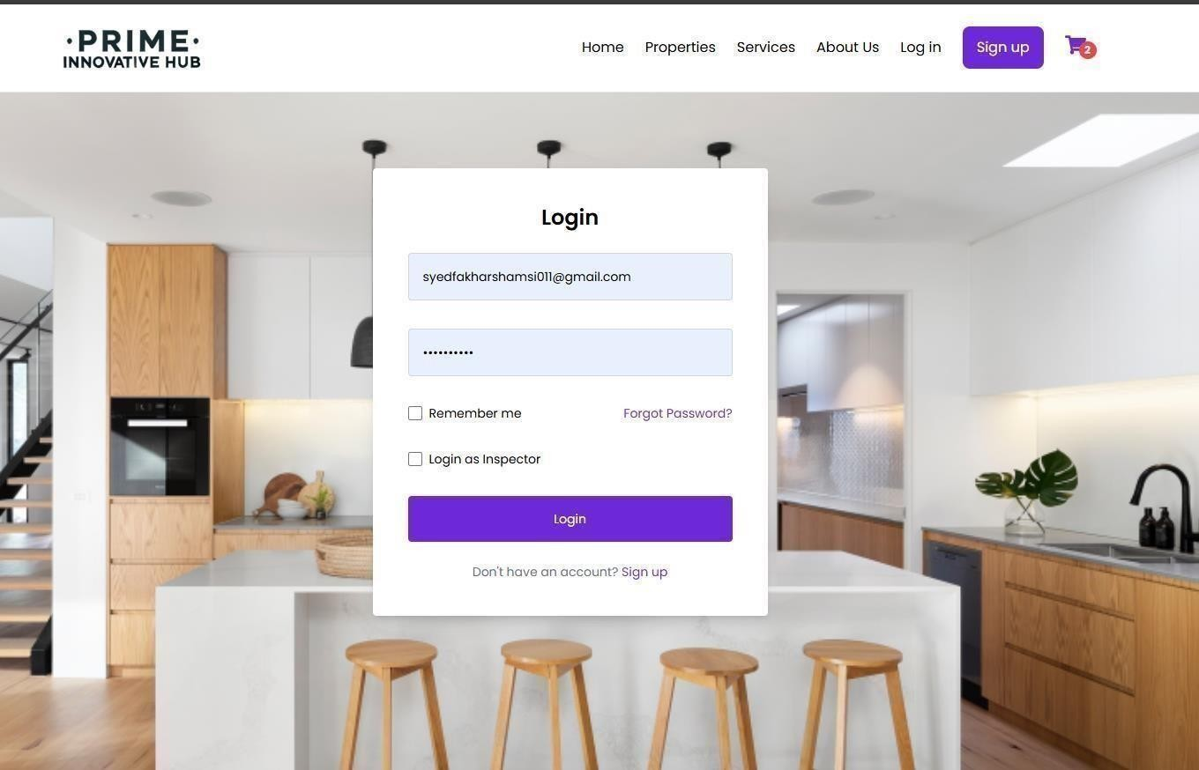

**Description:** This screenshot shows the login screen where users are required to enter their username and password.

**Steps to log in:**

1. **Open the login webpage** – Navigate to the web address provided to access the login screen.
2. **Enter login details** – Enter your valid username and password. These credentials are provided by the system administrator.
3. **Click "Login"** – After entering the correct details, click the "Login" button.

**Done** – Once logged in successfully, you will be directed to the appropriate user dashboard (Buyer, Seller, Inspector, Admin).

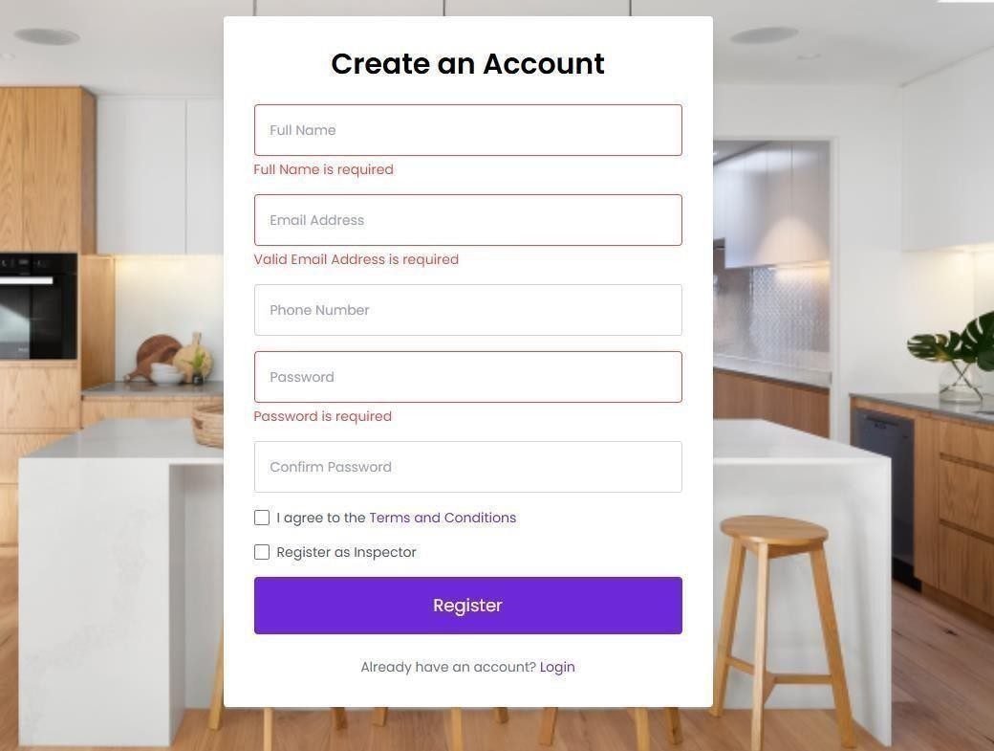

## 8.2 Property Listing Search

The property listing page allows users to search for properties based on various filters such as category, price range, and city.

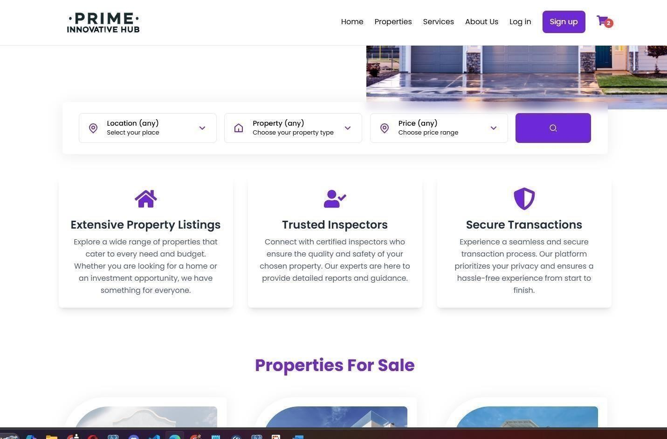

## Map View:

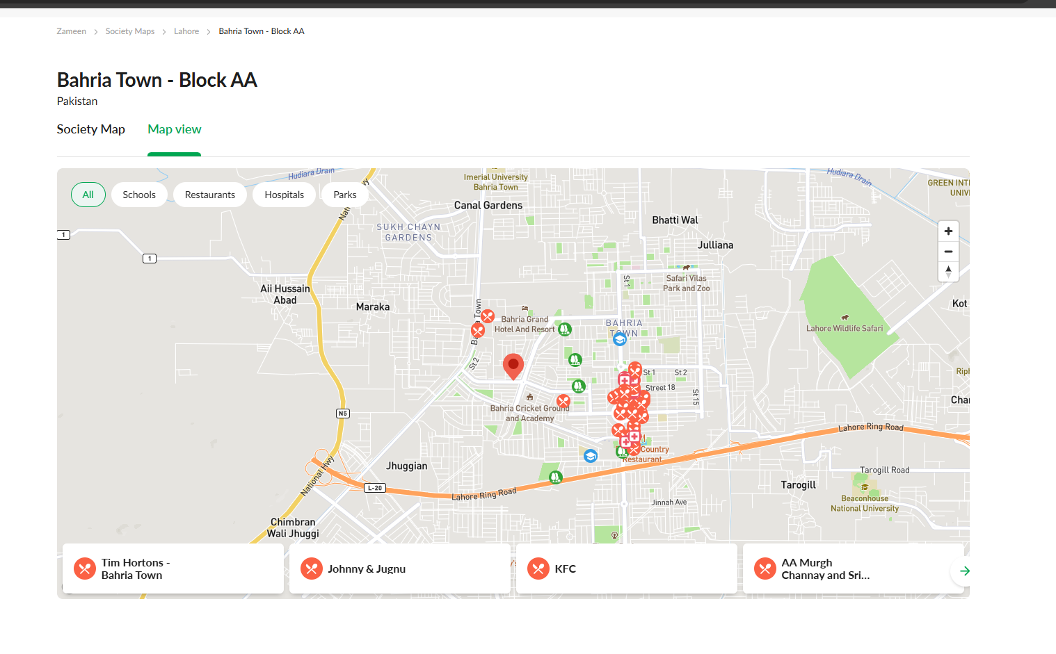

**Description:** This screenshot shows the property listing page with available filters such as category, city, and price range to help users find properties more easily.

**Steps to search for properties:**

1. **Go to the property listing page** – Open the page where all available properties are listed.
2. **Apply filters** – Select the category, city, and price range to narrow down the property search.
3. **View filtered properties** – Once filters are applied, the properties that match your criteria will be displayed.
4. **Click on a property** – To view the detailed information, click on a property from the list.

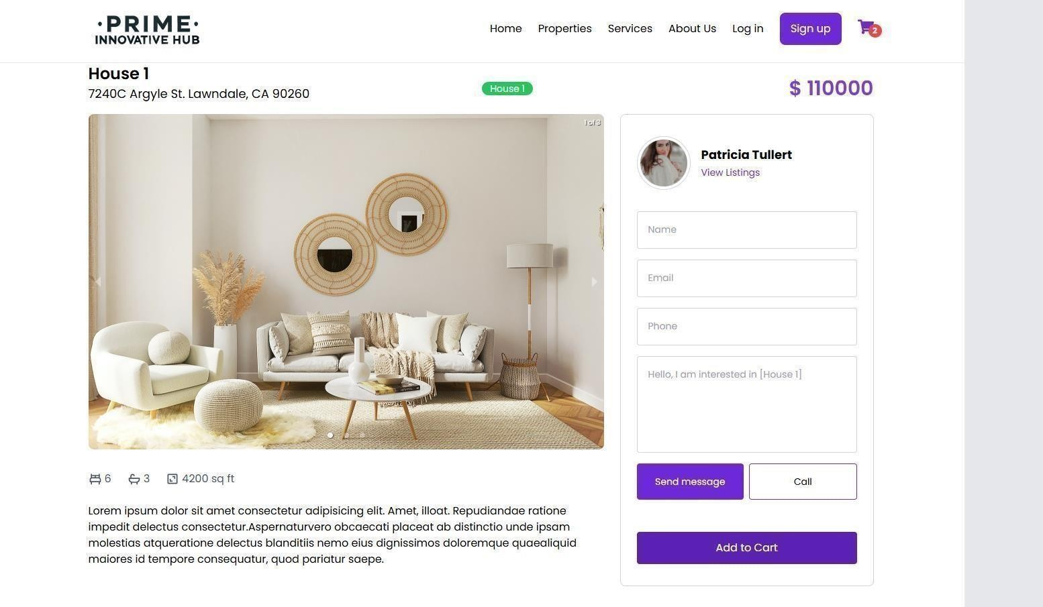

## 8.2 Booking an Inspection Slot

Buyers can book inspection slots by selecting available inspectors and choosing a suitable date and time.

**Inspector Selection and Booking Form**

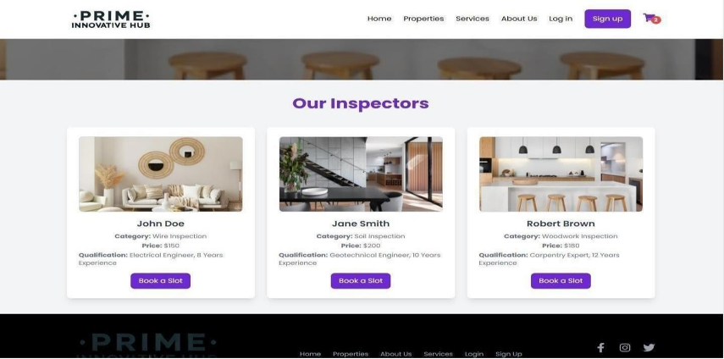

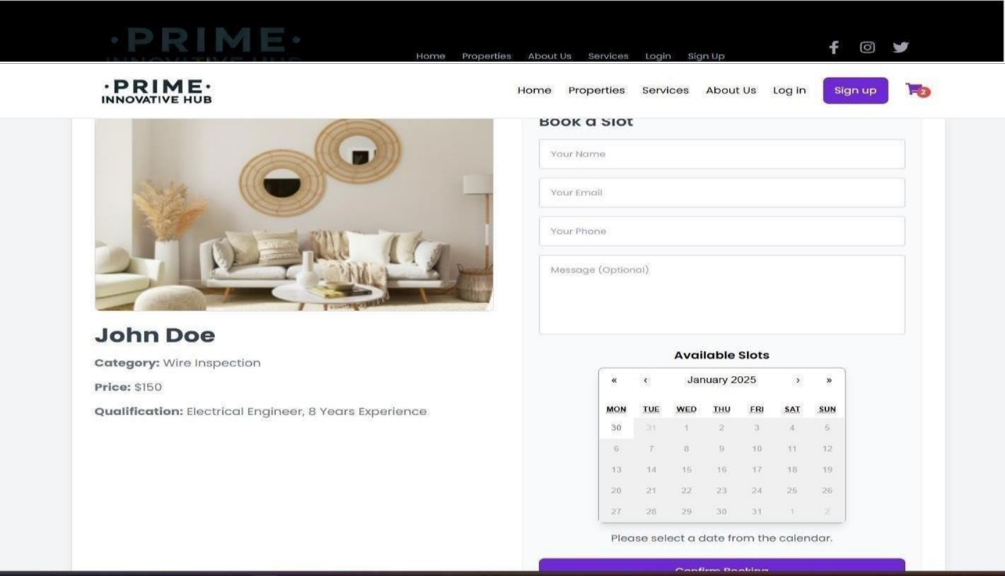

**Description:** This screenshot shows the inspector details page with an option to book an inspection. It also shows the booking form where the buyer can fill in their details and choose a time slot.

**Steps to book an inspection:**

1. **Go to the inspector details page** – After selecting an inspector from the service list, you will be redirected to the inspector’s profile.
2. **Fill in your details** – Enter your name, email, phone, and any message you want to send to the inspector.
3. **Select available time** – Choose a date and time from the available slots.
4. **Confirm booking** – Click the "Confirm Booking" button to submit the request.

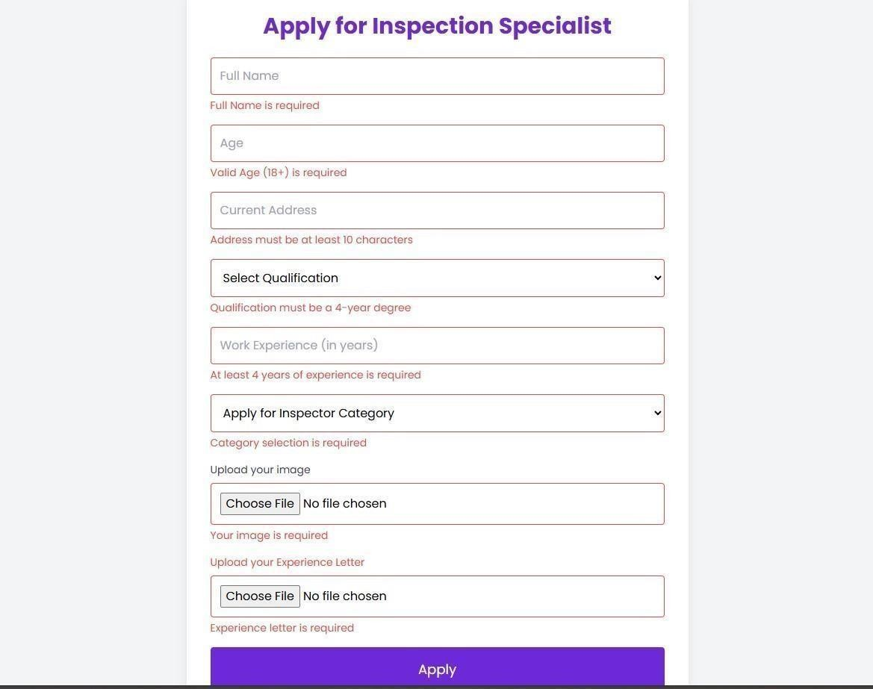

## 8.4 Profile Management (Seller/Inspector)

Sellers and Inspectors can manage their profiles, including updating personal details and adding available slots for inspections.

**Profile Edit Screen**

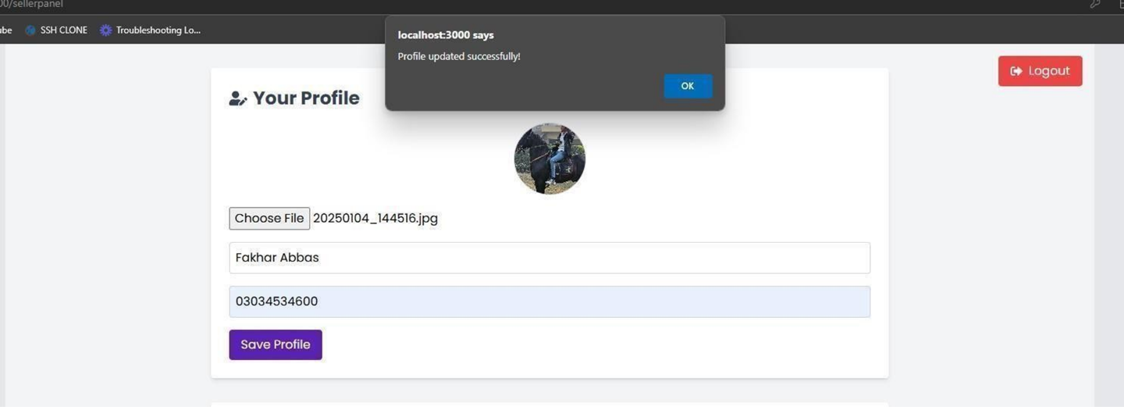

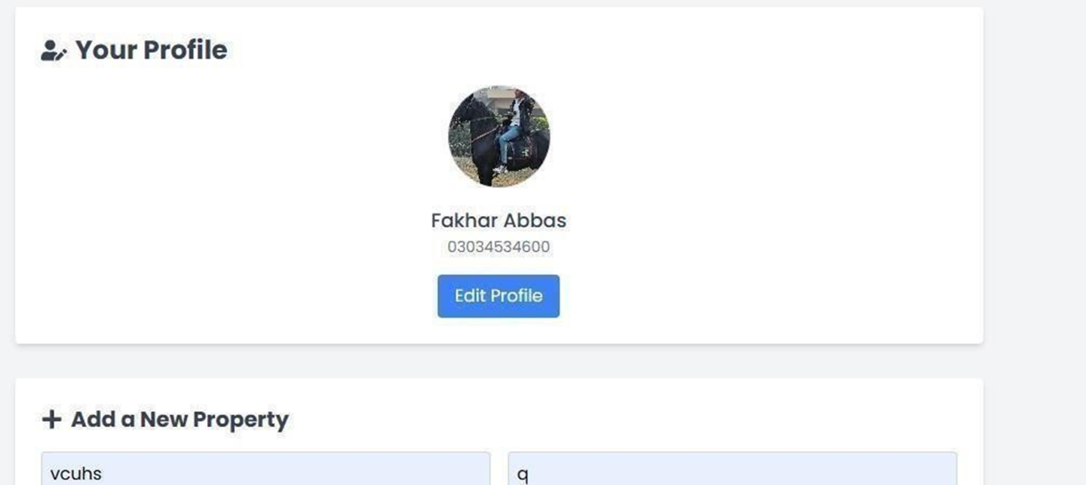

**Description:** This screenshot shows the profile page where the user can update their name, email, phone number, and image. Inspectors can also update their available time slots here.

**Steps to update your profile:**

1. **Go to the profile page** – Navigate to the profile section from the main dashboard.
2. **Edit personal details** – Update your name, email, phone number, or image by filling in the fields.

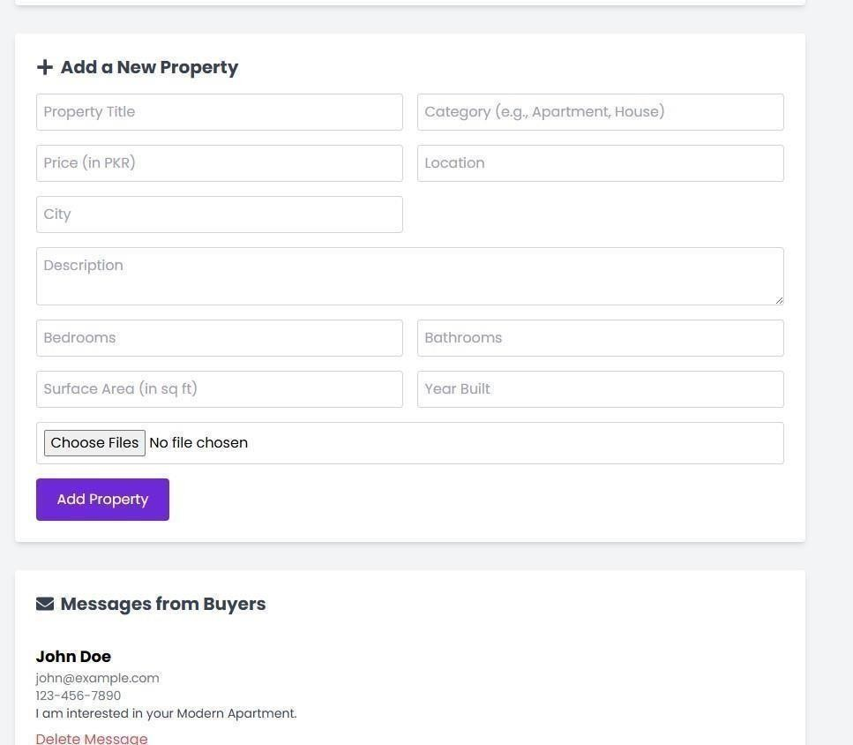

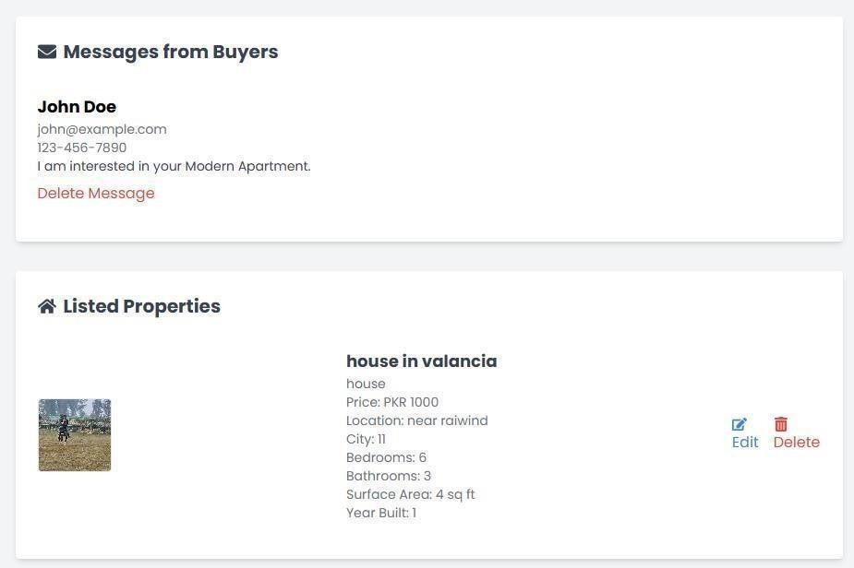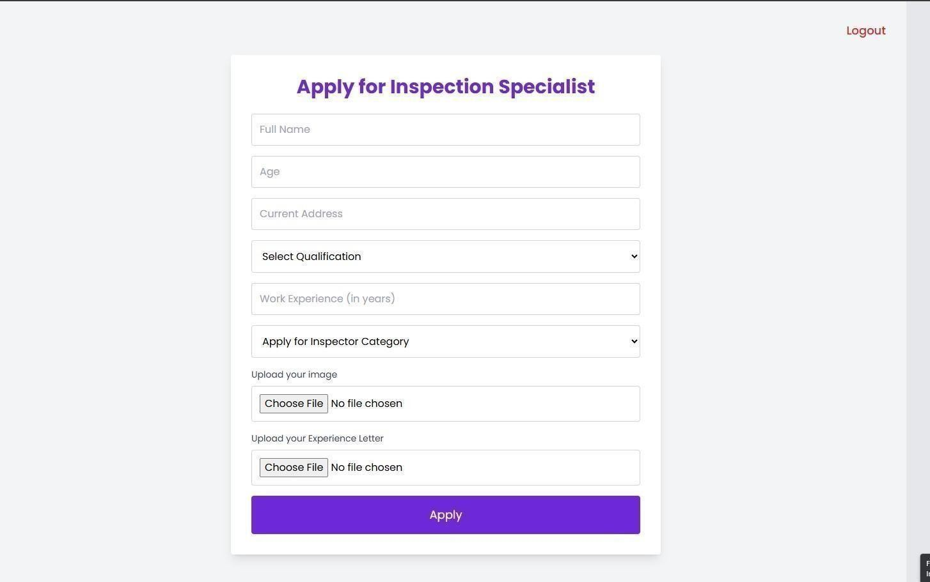

## Inspector Dashboard:

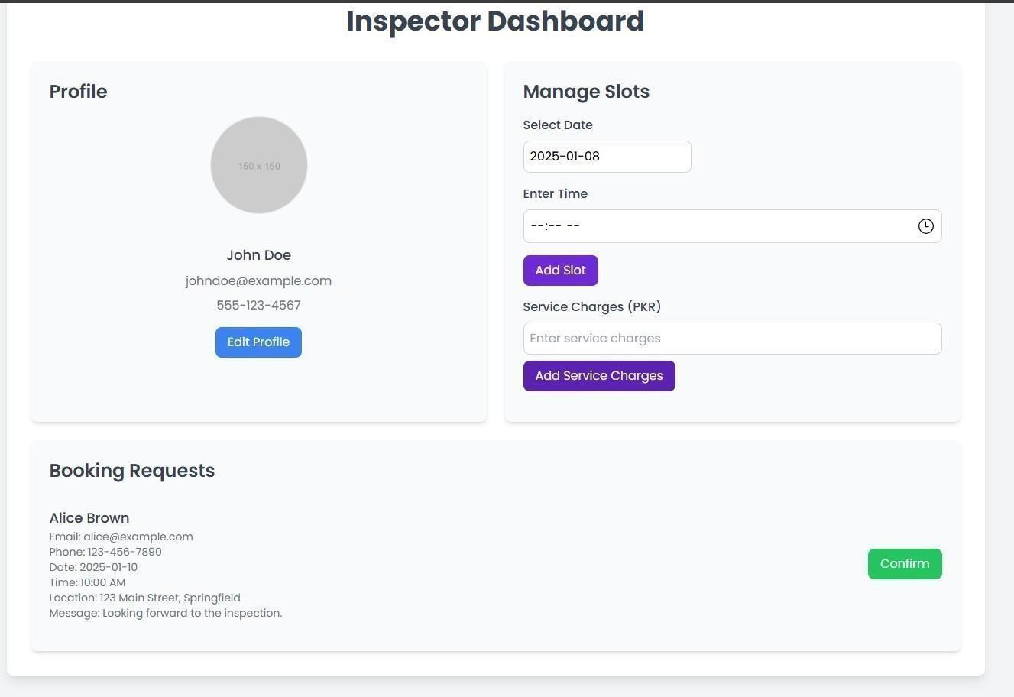

## Chatbot:

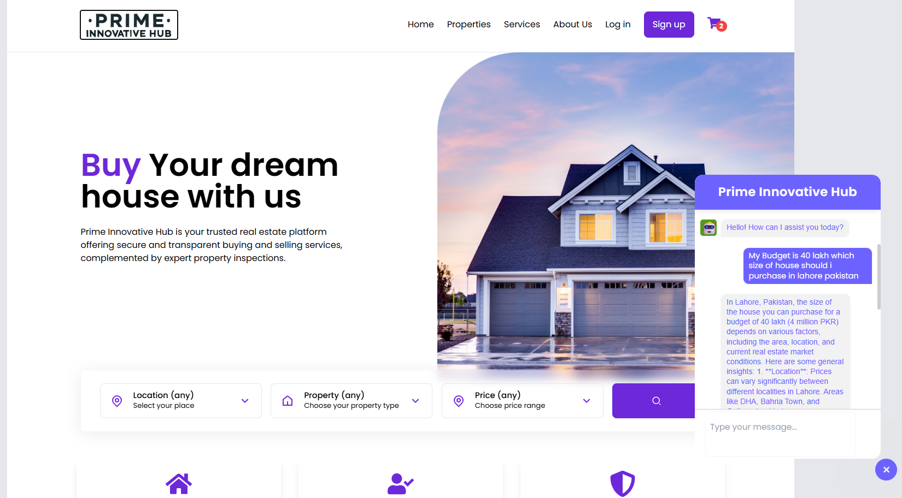

## Admin Dashboard:

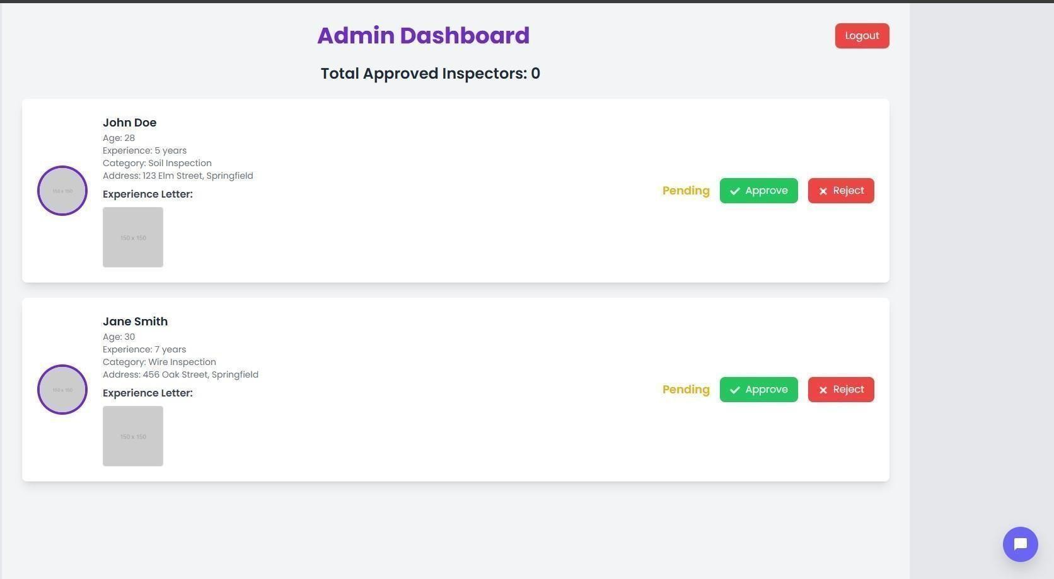

# Chapter 9: Lessons Learnt and Future Work

## ****Lessons Learnt****

Through the design and development of our AI-integrated real estate web application, we acquired essential technical skills, team coordination experience, and real-world development insights:

1. **Full-Stack Integration Skills**  
   By working with ReactJS on the frontend and NestJS on the backend, we gained hands-on experience in full-stack web development. We successfully connected these technologies using REST APIs with PostgreSQL for persistent data storage.
2. **State Management with Redux Toolkit**  
   Redux Toolkit helped streamline global state management. This taught us how to optimize frontend performance using data caching and query abstraction.
3. **Map Integration via Google Maps API**  
   Implementing Google Maps allowed us to visualize properties and inspector locations, enhancing the user experience. We learned to convert real-time location data into meaningful insights.
4. **AI Chatbot with OpenAI Integration**  
   We integrated a chatbot to assist users in searching for properties and asking questions about buying, renting, or inspections. This taught us about NLP capabilities and user interaction flow in AI services.
5. **Role-Based Access Control (RBAC)**  
   Designing separate dashboards for sellers, inspectors, admins, and customers improved our understanding of secure user authentication, routing, and dashboard isolation.
6. **API Testing and Debugging**  
   We tested and debugged endpoints using tools like Postman. This ensured that the backend APIs were reliable and all endpoints responded appropriately with valid input/output.
7. **Team Collaboration & Version Control**  
   Through tools like Git and GitHub, we collaborated effectively as a team. We also practiced proper documentation, code reviews, and continuous integration workflows.

## ****Future Work****

To further improve and evolve the real estate web platform, we propose the following future enhancements:

1. **Real-Time Chat System**  
   Integrate a secure real-time messaging module (e.g., using WebSockets) to allow users, sellers, and inspectors to communicate directly within the platform.
2. **Mobile Application**  
   Create a cross-platform mobile version using React Native for improved accessibility and user reach.
3. **AI-Driven Recommendations**  
   Upgrade the chatbot to suggest properties or services based on user behavior and previous interactions using machine learning.
4. **Multilingual Support**  
   Add language localization for Urdu, Arabic, and French, making the platform more accessible to global users.
5. **Document Upload & Verification**  
   Allow inspectors and sellers to upload documents (ownership proof, certification, etc.) for verification by the admin.
6. **Advanced Admin Analytics**  
   Implement analytics dashboards for the admin to monitor user activity, inspector approvals, most searched locations, and fraud detection.

# ****References****

### ****Books****

[1] B. Hogan, React Explained: A Full-Stack Guide to React Framework, San Francisco, CA: Code4Coders Press, 2020.

[2] D. Schell, Learning PostgreSQL, Birmingham: Packt Publishing, 2018.

### ****Book Chapters****

[3] A. K. Singh, “Introduction to NoSQL and Relational Databases,” in Modern Database Systems, J. P. Gupta, Ed. New York: Wiley, 2021, pp. 45–72.

### ****Electronic Books****

[4] T. R. Miller. (2024, Aug. 10). Mastering NestJS for Backend Development [Online]. Available: <https://nestjsbook.com/>

### ****Journal Articles****

[5] R. Malik, “Google Maps API and its Application in Smart Web Apps,” Int. J. of Web Engineering, vol. 13, no. 4, pp. 112–118, Nov. 2023.

### ****E-Journal Articles****

[6] M. Khan. (2024, Mar.). “AI Chatbots in Real Estate Platforms,” Journal of Digital AI [Online]. vol. 18, no. 1, pp. 60–68. Available: https://journalofdigitalai.com/real-estate-bots

### ****Conference Papers****

[7] F. Ahmed and N. Qureshi, “Location-Based Property Search Using Google Maps API,” in Proc. 2023 Int. Conf. on Smart Technologies, Lahore, Pakistan, 2023, pp. 88–92.

### ****Theses / Dissertations****

[8] H. R. Ali, “A Role-Based Real Estate Web Platform Using Full-Stack Technologies,” B.S. thesis, Dept. Software Eng., COMSATS Univ., Islamabad, Pakistan, 2025.

### ****Online Documents****

[9] NestJS. “NestJS: A progressive Node.js framework” [Online]. Available: https://docs.nestjs.com/

[10] OpenAI. “OpenAI API Documentation” [Online]. Available: <https://platform.openai.com/docs/>

[11] PostgreSQL. “PostgreSQL Official Docs” [Online]. Available: <https://www.postgresql.org/docs/>

[12] Redux Toolkit. “Redux Toolkit Documentation” [Online]. Available: https://redux-toolkit.js.org/

[13] Google Developers. “Google Maps JavaScript API Documentation” [Online]. Available: https://developers.google.com/maps/documentation/javascript

# ****Appendix****

The appendix contains supplementary materials that support the implementation of the real estate platform. These documents are too detailed to be included in the main chapters but are essential for full system understanding.

## ****Appendix A: Database Schema****

* Entity Relationship Diagram (ERD)
* Tables:
  + Users
  + Properties
  + Services
  + Contacts

## ****Appendix B: Sample Code Snippets****

* NestJS sample route for creating a property
* ReactJS sample for dynamic filtering with Redux Toolkit Query
* Google Maps API initialization and location markers
* OpenAI chatbot integration code with response management

## ****Appendix C: UI Snapshots****

* Home Page with property filters
* Inspector Dashboard
* Seller Panel CRUD form
* Google Map with Inspector pins
* Registration and login forms

## ****Appendix D: Test Cases****

* Black-box tests for registration and login
* White-box tests for API request validation
* Integration test for role-based dashboard redirects